SENIOR FIVE TERM 3

TOPIC 1/2: National Income
Competency: The learner assesses the impact of various income variables on community development, by collecting and analysing relevant data on macroeconomic indicators and income distribution, to inform the decisions of community actors.

National income
National income is the total value of all incomes earned by the residents of a country in a given period (usually one year). It is usually measured using the income method, which sums up the earnings of the factors of production

Components of National Income
- Wages and Salaries: Income earned by labor in the form of wages, salaries, and other compensation.
- Rent: Earnings from land and property used in production.
- Interest: Payments to capital owners for lending funds or investing in productive activities.
- Profits: Earnings of entrepreneurs after covering costs, including dividends and retained earnings.
- Mixed Incomes: Incomes of self-employed individuals, which combine wages, profits, and sometimes rent.
- Net Factor Income from Abroad (NFIA): Difference between income earned by residents abroad and income paid to foreign factors working domestically.
- Taxes on Production and Imports minus Subsidies: Indirect taxes (like VAT, excise duty) add to national income, while subsidies reduce it.
- Depreciation: Adjustments Deducting depreciation of capital assets gives Net National Product (NNP).

Determinants of national income
- Availability of Natural Resources: Abundant land, minerals, water, and favorable climate increase production capacity and income.
- Capital Formation: Investment in machinery, infrastructure, and technology boosts productivity and national income.
- Labor: Force The size, skill, and efficiency of the workforce directly affect output levels.
- Level of Technology: Advanced technology improves efficiency, reduces costs, and raises production.
- Political Stability and Governance: Stable governments encourage investment, trade, and economic growth.
- Industrialization: A strong industrial base increases output, employment, and income.
- Foreign Trade: Export earnings and favorable trade balances contribute to higher national income.
- Infrastructure: Development Efficient transport, communication, and energy systems support production and distribution.
- Education and Human Capital: Skilled and educated workers enhance productivity and innovation.
- Monetary and Fiscal Policies: Government policies on taxation, spending, and money supply influence investment and consumption.
- Market size within and outside the country. The large market encourages investors which lead to the production of more goods and services hence increasing national income. But a small market discourages investment and production hence low level of national income.
- The level of monetization of the economy. The higher the level of monetization of the economy, the higher the level of national income. But a large subsistence sector discourages production and exchange hence low levels of income.
- Level of specialization in production. The higher the level of specialization in the economy, the higher the level of national income and the lower the level of specialization, the lower the level of national income
- The level of entrepreneurial ability. Presence of individuals who can organize and mobilize other factors of production leads to an increase in production hence an increase in national income and absence of entrepreneurial skills discourages production hence low levels of national income.

Examples in Uganda
- Agriculture: Fertile soils and favorable climate contribute significantly to Uganda’s national income.
- Telecommunications: Investment by MTN and Airtel in mobile money services boosts capital formation and technology adoption.
- Tourism: Natural attractions like national parks and the River Nile generate foreign exchange earnings.
- Political Stability: Stability encourages foreign investment and trade partnerships.

Concepts (terms) used in national income
- Gross Domestic Product (GDP): Total value of all final goods and services produced within a country’s borders in a given period.
GDP=C+I+G
where, C= Consumption (Household) sector; I = Investment (Business) sector and G = Government sector
- Gross National Product (GNP): GDP plus net income earned by residents from abroad (income from exports, investments, etc.).
- Net National Product (NNP): GNP minus depreciation (wear and tear of capital assets).
- National Income (NI): Total income earned by residents of a country, including wages, rent, interest, and profits.
- Personal Income (PI): Income actually received by individuals, including transfer payments (like pensions, subsidies).
- Disposable Income (DI): Personal income minus taxes; the amount households can spend or save.
- Per Capita Income: National income divided by population, showing average income per person.
- Net Factor Income from Abroad (NFIA): Difference between income earned by residents abroad and income paid to foreign factors domestically.
- Real National Income: National income adjusted for inflation, showing actual purchasing power.
- Nominal National Income: National income measured at current market prices, without adjusting for inflation.
Real income =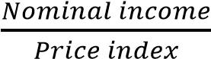

Examples in Uganda
- GDP: Value of goods produced in Uganda, such as coffee, fish, and manufactured goods.
- GNP: Includes Ugandans’ earnings abroad, e.g., remittances from workers in the Middle East.
- Disposable Income: What households have left after paying taxes, used for consumption and savings.
- Per Capita Income: Helps compare Uganda’s average living standards with other countries.

Transfer Payments
Transfer payments are payments made by the government (or other institutions) to individuals or groups without any exchange of goods or services in return. They are essentially redistributions of income, not part of production, and therefore not included in national income calculations

Features of Transfer Payments
- No quid pro quo: Recipients do not provide goods or services in exchange.
- Redistributive in nature: Aim to reduce inequality and support vulnerable groups.
- Non-productive: Do not directly contribute to current output or GDP.
- Government-funded: Usually financed through taxation or borrowing.
- Social welfare focus: Targeted at improving living standards of disadvantaged groups.

Examples of Transfer Payments
- Pensions: Payments to retired workers.
- Scholarships: Financial aid to students.
- Unemployment benefits: Support for jobless individuals.
- Subsidies: Assistance to farmers or businesses.
- Grants and donations: Aid to NGOs or communities.
- Social security payments: Support for the elderly, disabled, or low-income households.

Examples in Uganda
- Government bursaries and scholarships: Support for students from low-income families.
- NAADS subsidies: Assistance to farmers under the National Agricultural Advisory Services program.
- Social welfare programs: Cash transfers to vulnerable households.
- Pensions for retired civil servants: Monthly payments to former government employees.

Adjustments in National income Figures
- Depreciation (Capital Consumption): Deducting the wear and tear of capital assets from Gross National Product (GNP) to arrive at Net National Product (NNP).
- Indirect taxes (e.g., VAT, excise duty) are added because they increase market prices.
- Subsidies are subtracted since they artificially lower prices.
- Net Factor Income from Abroad (NFIA): Adjusting for income earned by residents abroad minus income paid to foreign factors working domestically. Are added to GDP to get GNP.
- Transfer Payments: Excluded from national income since they are not payments for productive services (e.g., pensions, scholarships).
- Inflation Adjustment: Converting nominal national income into real national income to reflect actual purchasing power.
- Inventory Changes: Adjusting for changes in stock levels of goods, as they affect production measurement.
- Double Counting Avoidance: Ensuring only final goods and services are included, not intermediate goods.
- Illegal/Unrecorded Activities: Excluded because they are not part of official economic activity, though they may exist in reality.
Examples in Uganda
- Depreciation: Deducting wear and tear of machinery in industries like cement production.
- Indirect Taxes: VAT on goods sold in Kampala markets is added to national income figures.
- Subsidies: Government support to farmers under NAADS is subtracted.
- NFIA: Remittances from Ugandans working abroad are added to GNP.
- Transfer Payments: Scholarships and pensions are excluded from national income.

The circular flow of income in a closed and open economy
The circular flow of income is a model that shows how money, goods, and services move between different sectors of the economy. It explains how households, firms, government, and the foreign sector interact.

Circular Flow in a Closed Economy (No foreign trade)
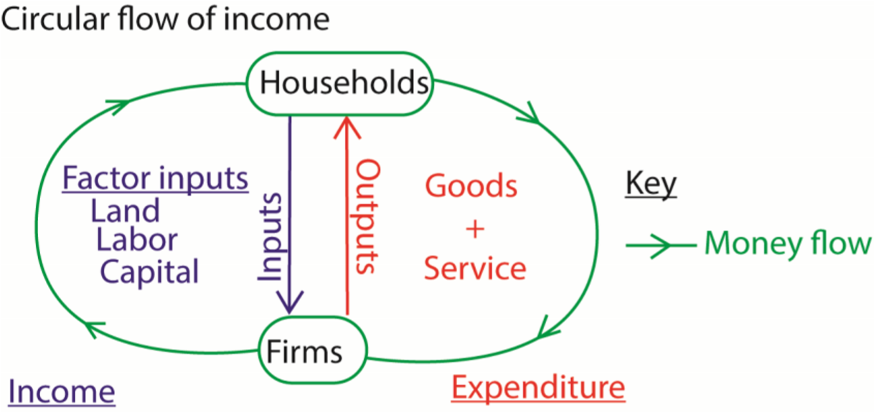
- Households Provide factors of production (land, labor, capital, entrepreneurship) to firms.
- Firms Use these factors to produce goods and services.
- Factor Payments Firms pay households wages, rent, interest, and profits.
- Consumption Expenditure Households spend their income on goods and services produced by firms.
- Government (optional in closed model) Collects taxes and provides public goods and services.
In a closed economy, the flow is between households and firms only, with no imports or exports. Circular Flow in an Open Economy (With foreign trade)
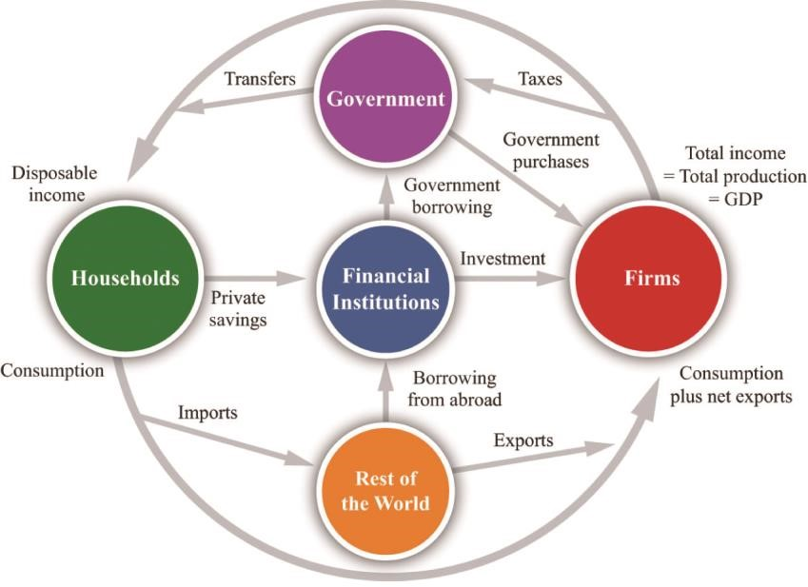
- Households Provide factors of production and consume goods/services.
- Firms Produce goods/services and pay households for factor inputs.
- Government Collects taxes, spends on public services, and influences the economy through fiscal policy.
- Foreign Sector o Exports: Goods/services sold abroad bring income into the economy. o Imports: Goods/services bought from abroad send income out of the economy. o Net Exports (X – M): The difference affects national income.
In an open economy, the flow includes international trade and capital flows, making it more realistic.

Why circular flow of income Matters
- In a closed economy, national income depends only on domestic production and consumption.
- In an open economy, national income is influenced by exports, imports, and foreign investments, making it dynamic and globally connected.

The equilibrium position of National Income in Closed and Open Economies
The equilibrium level of national income is the point where aggregate demand (AD) equals aggregate supply (AS). At this position, the economy’s output and income remain stable unless disturbed by external shocks.
Illustration
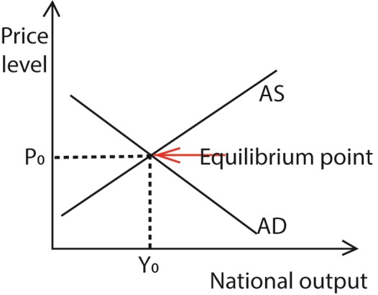

Equilibrium in a Closed Economy
Key Condition: Y = C + I Where:
Y = National Income
C = Consumption expenditure I = Investment expenditure
Explanation:
- Households spend income on consumption. o Firms invest in capital goods.
- Equilibrium occurs when total spending (C + I) equals total output (Y).
- If C+I>Y, output rises; if C+I<Y, output falls until equilibrium is restored.

Equilibrium in an Open Economy
Key Condition: Y = C+I+G+(X−M)
Where:
Y = National Income
C = Consumption
I = Investment
G = Government expenditure
X = Exports M = Imports Explanation:
- In addition to consumption and investment, government spending and net exports (exports minus imports) affect equilibrium.
- If exports exceed imports, national income rises; if imports exceed exports, national income falls.
- Fiscal policy (taxation and spending) and trade flows play a crucial role in determining equilibrium.

Comparison
Aspect | Closed Economy | Open Economy
Equation | Y=C+I | Y=C+I+G+(X−M)
Sectors Involved | Households + Firms | Households + Firms + Government + Foreign sector
Determinants | Consumption, Investment | Consumption, Investment, Government spending, Net exports
Stability Factors | Domestic demand only | Domestic + international trade + fiscal policy
Example | Uganda’s rural subsistence economy | Uganda’s national economy with exports (coffee, fish) and imports (machinery, fuel)

Uses of national income statistics
- Measuring Economic Growth: Track changes in GDP and GNP over time to assess whether the economy is expanding or contracting.
- Policy Formulation: Governments use national income data to design fiscal and monetary policies (taxation, spending, interest rates).
- International Comparisons: Compare living standards and development levels across countries using per capita income and GDP.
- Distribution of Income: Analyze inequalities in income and wealth, guiding social welfare and poverty reduction programs.
- Investment Decisions: Businesses and investors rely on national income trends to forecast demand and plan expansions.
- Sectoral Analysis: Identify contributions of agriculture, industry, and services to national income, guiding resource allocation.
- Standard of Living Measurement: Per capita income and real national income help evaluate citizens’ welfare and purchasing power.
- Budget Preparation: Governments use national income figures to estimate revenue, plan expenditures, and manage deficits.
- Balance of Payments Analysis: Helps track foreign trade performance and external economic relations.
- Development Planning: Guides long-term strategies for infrastructure, education, and industrialization.
- They show the pattern of expenditure by the private sector and the government. This is shown by figures of private expenditure which is important in making the National budget where there is need to balance between private and public expenditures.
- National income figures are used to attract foreign investment into the country. National income figures are an indicator to the outside world about the performance of the economy.
High and increasing national income figures encourage foreigners to invest in the economy.
- National income figures are used to solicit for foreign aid. Donor countries and other financial organizations base on national income figures to give foreign aid.

Examples in Uganda
- Economic Growth: Uganda tracks GDP growth driven by agriculture (coffee exports) and services (telecom, banking).
- Policy Formulation: National income data informs tax reforms and investment in public infrastructure.
- International Comparisons: Uganda’s per capita income is compared with East African neighbors to assess competitiveness.
- Sectoral Analysis: Statistics show agriculture still contributes significantly, but services are growing rapidly.

Methods (approaches) of measuring national income
Economists use three main approaches to measure national income. Each method captures the economy from a different angle, and each has strengths and limitations.

1. Product (Output) Method
Measures national income by summing the value of all final goods and services produced in the economy.
Equation:
Strengths
- Comprehensive view of production: Shows the contribution of different sectors (agriculture, industry, services).
- Useful for sectoral analysis: Helps policymakers identify growth drivers. (iii) Direct measure of output: Reflects actual production levels.
Limitations
- Double counting risk: Intermediate goods may be mistakenly included.
- Difficult to value services: Non-market activities (household work) are excluded.
- Informal sector challenges: Hard to capture unrecorded or subsistence production.
- It is difficult to determine when output was produced e.g. perennial crops.
- The effect of inflation is difficult to adjust and is likely to be misinterpreted as increase in output.
- Lack of information on what is produced by all enterprises or sectors within a year in
the economy
- Problem of inventories. Inventories are goods produced but not sold in the previous period. The value of such goods is not supposed to be included when estimating the national income of the current year.

2. Income Method
Measures national income by summing all factor incomes: wages, rent, interest, and profits.
Equation:
NI= Wages + Rent + Interest + Profits
Strengths
- Focus on distribution: Shows how income is shared among factors of production.
- Useful for policy: Helps design taxation and welfare programs.
- Avoids double counting: Only factor payments are included.
Limitations
- Data collection difficulties: Informal incomes and self-employment are hard to measure.
- Transfer payments confusion: Must be excluded since they are not earned income.
- Hidden incomes: Tax evasion and unreported earnings distort accuracy.
- Depreciation incurred during the year is difficult to determine yet an allowance for this must be included when estimating national income. Depreciation represents the cost of production since the asset must be replaced when it becomes completely won out.
- It is also difficult to identify incomes from illegal activities since they are not supposed to be included in estimating national income
- Shortage of qualified and motivated manpower to compile data

3. Expenditure Method
Measures national income by summing all spending on final goods and services.
Equation: NI=C+I+G+(X−M)
Where:
C = Consumption
I = Investment
G = Government expenditure
X−M = Net exports
Export (X) are included because they lead to inflow of income while Imports (M) are excluded because they lead to outflow of income

Strengths
- Captures demand side: Shows how national income is spent.
- Useful for macro policy: Helps manage inflation, demand, and trade balance.
- Clear structure: Easy to classify into consumption, investment, government, and trade.
Limitations
- Excludes non-market activities: Household production and barter are not counted.
- Data reliability issues: Requires accurate records of spending, which may be incomplete.
- Price changes distortion: Inflation can misrepresent real expenditure.
- Government utilities like roads, security etc. are usually subsidized and thus it is difficult to determine their actual value.
- Net exports and income earned from abroad are not easy to determine. For example foreign exchange from smuggled output is unknown; some income earned abroad is not declared and therefore not recorded.
- There is insufficient funds and facilities to compile data
- Illegal activities e.g. prostitution, gambling, smuggling generate income which is difficult to measure.

Comparison Table
Method | Strengths | Limitations
Product Method | Comprehensive view of production; useful for sectoral analysis | Risk of double counting; excludes informal sector
Income Method | Focus on income distribution; avoids double counting | Hard to measure informal/hidden incomes; excludes transfer payments
Expenditure Method | Captures demand side; useful for macro policy | Excludes non-market activities; inflation distorts values

Why most developing countries prefer to use the Product approach
- Data on output is readily available as compared to data on income and expenditure
- Individuals are willing to reveal information on output than on income and expenditure
- It eliminates double counting since only value added is considered
- The approach is not affected by transfer payment as for the case of income and expenditure approaches.
- It does not include the effects of illegal activities

Problems involved in calculating (estimating) National income
Accurate national income statistics are essential for policy-making, planning, and international comparisons. But these problems identified below mean figures are often approximations rather than exact measures.
- Non-Monetized Sector: In countries like Uganda, a large portion of production (subsistence farming, barter trade) is not recorded in monetary terms.
- Informal Economy: Many small businesses and self-employed individuals operate outside official records, making data collection incomplete.
- Double Counting: Including intermediate goods (like raw materials) along with final goods can inflate national income figures.
- Valuation of Services: Difficult to measure services such as household work, volunteer activities, and informal caregiving.
- Transfer Payments: Pensions, scholarships, and subsidies must be excluded since they are not payments for productive services, but separating them accurately is challenging.
- Depreciation Measurement: Estimating wear and tear of capital assets is subjective and often inaccurate.
- Illegal/Unrecorded Activities: Smuggling, black-market trade, and unreported incomes are excluded, though they contribute to economic activity.
- Price Changes (Inflation): Inflation distorts nominal income figures, making it hard to compare across years without adjustments.
- Data Collection Difficulties: Lack of reliable statistics, especially in developing countries, leads to incomplete or outdated information.
- International Comparisons: Different countries use varying methods and definitions, making cross-country comparisons problematic.
- Poor social and economic infrastructure. For example inaccessible roads, poor communication networks and limited banking facilities limit the national income estimation exercise.
- Inadequate skilled and qualified personnel. There is a limited number of staticians, economists and accountants required to collect, compute analyze and interpret national income figures.
- Political instabilities and insecurity in some parts of the country. This makes it difficult to access some parts of the country to collect data for purposes of estimating national income (xiv) Inadequate funding of the statistic department

Examples in Uganda
(xv) Subsistence farming: Most rural households consume what they produce, making it hard to record.
- Informal trade: Street vendors and boda-boda riders often operate outside official taxation systems.
- Depreciation: Estimating wear and tear of agricultural tools or small machinery is difficult.
- Inflation: Rising food and fuel prices distort real income figures.

Per Capita Income
Per capita income is the average income per person in a country, calculated by dividing national income (or GDP) by the total population in a particular year.
Per capita income = 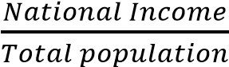
Purpose:
- Measures the economic output or income available per person.
- Used for international comparisons of economic development.
- Indicates the average standard of living, though not perfectly.
Limitations:
- Does not show income distribution (inequality).
- May be misleading in countries with high population growth or large informal sectors.
- Ignores non-monetary aspects of welfare (health, education, and environment).

Standards of Living
Standards of living refer to the overall quality of life enjoyed by people, including both material and non-material aspects.
Components of standard of living:
- Material welfare: Income, consumption, housing, clothing, food.
- Social welfare: Education, healthcare, security, leisure.
- Environmental factors: Clean water, sanitation, pollution levels.
- Freedom and equality: Political stability, human rights, social justice.
Measurement Tools for standard of living:
- Per capita income (economic indicator).
- Human Development Index (HDI): Combines income, education, and life expectancy.

(iii) Quality of Life indices: Broader measures including health, environment, and happiness. Relationship Between the Per Capita Income and Standard of Living
Aspect | Per Capita Income | Standard of Living
Nature | Purely economic measure | Broader social & economic measure
Focus | Average income per person | Quality of life (material + non-material)
Strength | Easy to calculate, useful for comparisons | More realistic measure of welfare
Limitation | Ignores inequality & social factors | Harder to measure, subjective

Cost of living
The cost of living refers to the amount of money needed to sustain a certain standard of life in a given place and time. It includes the expenses required for basic needs such as food, housing, clothing, healthcare, education, and transportation.

Key Features of Cost of Living
- Basic Needs Coverage: Measures the cost of essentials like food, shelter, and clothing.
- Location-Specific: Varies widely between countries, cities, and even rural vs urban areas.
- Time-Sensitive: Changes over time due to inflation, wage levels, and economic conditions.
- Comparative Tool: Used to compare living standards across regions or countries.
- Index Measurement: Often expressed through a Cost of Living Index, which compares expenses in one location to a base location.

Components of Cost of Living
- Housing: Rent, mortgage payments, utilities.
- Food and Groceries: Daily consumption needs.
- Transportation: Public transport, fuel, vehicle maintenance.
- Healthcare: Medical services, insurance, medicines.
- Education: School fees, books, supplies.
- Taxes: Income tax, property tax, indirect taxes.
- Miscellaneous: Clothing, entertainment, communication services.

Example in Uganda
- Housing: Rent in Kampala is significantly higher than in rural areas.
- Food: Prices of staples like matooke, beans, and maize vary depending on season and location.
- Transport: Boda-boda fares and fuel costs affect daily commuting expenses.
- Education: Private school fees are a major component of household expenditure.

Limitations of using per capita income in measuring standards of Living
- Ignores Income Distribution: Per capita income is an average; it does not show whether income is concentrated among a few or fairly distributed.
- Excludes Non-Monetary Welfare: Factors like health, education, leisure, and political freedom are not captured in income figures.
- Does Not Reflect Regional: Differences Living costs vary across regions (urban vs rural), but per capita income assumes uniformity.
- Affected by Population Size: Countries with high population growth may show low per capita income even if total national income is rising.
- Inflation Distortion: Nominal per capita income may rise due to inflation, without any real improvement in living standards.
- Excludes Informal and Subsistence Activities: In economies like Uganda, much production (subsistence farming, barter trade) is not monetized, so per capita income underestimates welfare.
- Does Not Capture Quality of Goods and Services: Higher income does not guarantee better healthcare, education, or housing quality.
- International Comparisons Misleading: Exchange rate differences and varying costs of living make per capita income comparisons across countries unreliable.
- Per capita income does not reflect the level of unemployment in the country. The per capita figures Play be high as a result of using capital intensive techniques of production yet the majority of the people have no jobs.
- Per capita income may increase as a result of underestimating population figures. This does not necessarily imply high standards of living.

Example in Uganda
- Income Distribution: A few urban elites earn high incomes, while rural farmers earn very little, yet the average per capita income hides this inequality.
- Non-Monetary Welfare: Improvements in mobile technology and healthcare access have raised living standards, even if per capita income remains low.
- Regional Differences: Living costs in Kampala are much higher than in rural areas, but per capita income does not reflect this.

Limitations of using per capita income in c omparing standards of living b e t w e e n countries
- Income Distribution Differences: Per capita income is an average and does not show inequality. Two countries may have the same per capita income, but one may have extreme income gaps while the other is more equal.
- Differences in Cost of Living: A dollar may buy more in one country than another. Without adjusting for purchasing power parity (PPP), comparisons are misleading.
- Population Size and Growth: Countries with large populations may show low per capita income even if total national income is high.
- Non-Monetary Welfare Factors: Health, education, political freedom, and environmental quality are ignored, yet they strongly affect living standards.
- Exchange Rate Distortions: Converting incomes into a common currency (like USD) can misrepresent real welfare due to fluctuating exchange rates.
- Informal and Subsistence Economies: In developing countries, much production (subsistence farming, barter trade) is not monetized, so per capita income underestimates welfare.
- Cultural and Social Differences: Standards of living depend on lifestyle, social values, and expectations, which income figures cannot capture.
- Inflation and Price Levels: Nominal per capita income may rise due to inflation, but real purchasing power may remain stagnant.
- Differences in the methods used to measure national income. The per capita income figures may be high when the country uses the expenditure approach instead of the output approach. The high expenditures may be as a result of the high prices of goods and services which does not reflect high standards of living.
- Differences in political climate between countries. The per capita income figures may be high when the country is experiencing political instabilities especially when the country uses the expenditure approach of measuring national income. This does not imply better standards of living.
- Differences in the quality and composition of goods and services consumed in different countries. A country may be having a high per capita income when the economy is concentrating on the production of capital goods which do not directly contribute to the welfare of the people.
- Differences in the levels of employment. Per capita income figures may be high when there are more unemployed people in one country as compared to the other. This does not imply better standards of living in that country.
(xiii)

Example
- Uganda vs USA: Uganda’s per capita income is far lower than the USA’s, but Ugandans may enjoy lower costs of food and housing compared to Americans.
- India vs Norway: India’s per capita income is lower, yet cultural factors like extended family support and informal networks contribute to welfare in ways not reflected in income figures.

Income distribution
Income distribution refers to how the total national income of a country is shared among its population, groups, or factors of production. It highlights whether wealth is spread evenly or concentrated in the hands of a few. Types of Income Distribution
- Functional Distribution: Division of income among factors of production: wages (labor), rent (land), interest (capital), and profits (entrepreneurship).
- Personal Distribution: How income is distributed among individuals or households, regardless of the source.
- Regional Distribution: Differences in income levels across regions (urban vs rural, developed vs underdeveloped areas).
- Sectoral Distribution: Distribution of income among different sectors of the economy (agriculture, industry, services).

Example in Uganda
- Functional Distribution: Farmers earn from land, workers from wages, and entrepreneurs from profits.
- Personal Distribution: Urban elites in Kampala earn much more than rural households.
- Regional Distribution: Central Region has higher incomes compared to Northern Uganda.
- Sectoral Distribution: Services (telecom, banking) contribute more income than agriculture, though most people depend on farming.

Income inequality (disparity)
Income inequality refers to the unequal distribution of income among individuals or groups within a society. It highlights the gap between the rich and the poor, showing how wealth and resources are concentrated in certain hands while others struggle with very little.

Income inequality (disparity) refers to the economic gap between the rich and the poor within the same country. The income disparities can be illustrated by the use of a Lorenz curve .The Lorenz curve shows the relationship between the population and its relative income share.

Lorenz Curve
The Lorenz Curve is a graphical representation of income distribution within a population. It shows the degree of inequality by comparing the cumulative share of income earned to the cumulative share of the population.
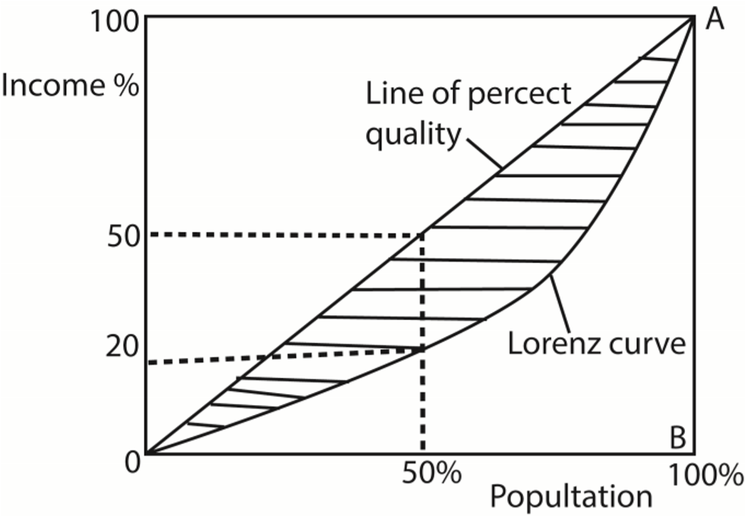
- The diagonal line OA (line of perfect equality) in the figure above shows that any point on the diagonal, any income received is exactly equal to the percentage of the population that receives it. Therefore the diagonal line represents perfect equality in the distribution of national income.

- However, i n reality perfect equality does not exist even in socialist economies. This illustrated by the Lorenz curve which shows the actual income 'distribution between the percentage recipients and the percentage of the total income they receive in a given time

- The more the Lorenz curve lies away from the perfect equality line, the greater the degree of income inequality

The Gini – coefficient
The Gini Coefficient is a widely used statistical measure of income inequality within a population. It is derived from the Lorenz Curve and provides a single number to summarize how evenly or unevenly income is distributed.
In the figure above, the gini - coefficient is the ratio of the shaded area to the total area of the triangle OAB
Gini coefficient = 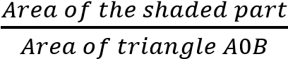
The gini - coefficient varies from zero to one.
The higher the coefficient, the higher the degree of income inequality.

Causes of Income Inequalities
- Education and Skills: Gap People with higher education and specialized skills earn more, while those with limited education remain in low-paying jobs.
- Unequal Asset: Ownership Land, property, and capital are often concentrated in the hands of a few, creating wealth gaps.
- Government Policies: Tax systems, subsidies, and welfare programs can either reduce or worsen inequality depending on how they are designed.
- Globalization: Skilled workers and large corporations benefit more from global trade, while unskilled laborers may be left behind.
- Inflation and Wage Stagnation: Rising prices without matching wage increases reduce the purchasing power of low-income households.
- Corruption and Governance Issues: Mismanagement of public resources and favoritism in contracts or jobs concentrate wealth among elites.
- Historical and Social Factors: Colonial legacies, racial discrimination, and unequal land distribution continue to shape inequality in many countries.
- Technological Change: Automation and digitalization reward high-skilled workers but displace low-skilled labor, widening the gap.
- Difference in talents (natural ability) those who are naturally talented e.g. footballers, musicians usually earn higher incomes than their counterparts that are not talented.
- Differences in resource endowment. Places rich in productive resources usually earn more than others
- Differences in opportunities/luck: people with good paying jobs earn more than others with low paying jobs
- Differences in age, sex, tribe and race; labour discrimination is based on these factors to determine individual income.
- Differences in infrastructure distribution. Area with even distribution of infrastructure tend to have high productivity hence higher incomes than others with under developed infrastructures
- Political stability/climate; areas that are politically stable attract investment than those that are unstable.
- Influence of trade unions. Strong and sound trade unions agitate for favorable conditions of work.

Example in Uganda
- Education Gap: Urban elites with university degrees earn far more than rural farmers with little schooling.
- Asset Ownership: Land distribution is highly unequal, with large estates owned by a few families. (iii) Regional Disparities: Kampala and Central Region enjoy higher incomes compared to Northern Uganda.
(iv) Globalization Impact: Export sectors (coffee, fish) benefit traders and exporters more than smallholder farmers.

Advantages (Merits) of income inequality
- Incentive for Hard Work: People are motivated to work harder, acquire skills, and innovate when higher incomes are possible.
- Encourages Investment: Wealthier individuals and firms invest in businesses, infrastructure, and technology, driving economic growth.
- Efficient Resource Allocation: Resources flow to those who can use them most productively, improving overall efficiency.
- Promotes Competition: Firms and individuals strive to outperform others, leading to better quality goods and services at lower prices.
- Supports Government Revenue: Higher incomes generate more tax revenue, which governments can use for public services and redistribution.
- Encourages Entrepreneurship: The possibility of earning higher profits motivates risk-taking and business creation.
- Consumer Choice Expansion: Income differences create demand for a wide range of products, from basic goods to luxury items, widening consumer options.
- It leads to the production of a wide range of commodities. This widens the choice to the consumers hence better standards of living through utility maximization.
- Income inequality guarantee labour supply to unattractive jobs like toilet cleaning
- Income inequality encourages geographical labour mobility where individuals move from one place to another in search for better opportunities.
- It helps to create more employment opportunities. The high profits are made by private individuals are used to expand business activities hence creating more employment opportunities.
- It promotes consumer sovereignty in the economy. This is because consumers are given freedom to decide on what to consume.
- There is no resource wastage during the production process. This is because resources are allocated with the aim of maximizing profits.

Example in Uganda
- Incentive for Hard Work: Professionals in Kampala pursue higher education and specialized skills to secure better-paying jobs.
- Encourages Investment: Wealthy Ugandans invest in real estate, banking, and agribusiness, boosting employment.
- Government Revenue: Higher-income earners contribute more taxes, funding infrastructure projects like roads and schools.

Disadvantages (demerits) of income inequality
- Poverty Persistence: Large gaps between rich and poor trap low-income groups in chronic poverty.
- Reduced Social Mobility: Inequality limits access to education, healthcare, and opportunities, making it harder for the poor to improve their lives.
- Lower Aggregate Demand: Poor households spend most of their income on necessities, while the rich save more. This reduces overall demand and slows economic growth.
- Social Tensions and Unrest: Wide disparities can lead to resentment, crime, and political instability.
- Political Inequality: Wealthy individuals may dominate politics, influencing policies to favor themselves rather than the majority.
- Brain Drain: Skilled workers may migrate to countries with fairer opportunities, weakening domestic development.
- Underutilization of Human Potential: When large sections of the population lack access to education and resources, their talents remain untapped.
- Health and Welfare Problems: Poorer households face malnutrition, poor healthcare, and shorter life expectancy compared to wealthier groups.
- Regional Gap: Kampala elites enjoy high incomes, while rural farmers remain poor.
- It increases government expenditure to support the majority poor in form of social services like education and health.
- Income inequality leads to balance of payment problems because of increased importation to satisfy the rich’s needs.
- Income inequality leads to profit repatriation when the rich are foreigners. This leads to slow development.
- Government revenue is reduced especially where the majority is poor.

Example in Uganda
- Education Access: Children from wealthy families attend better schools, while rural children often drop out early.
- Political Influence: Wealthy businesspeople have more say in policymaking compared to ordinary citizens.

Policy measures to reduce income inequality
- Progressive Taxation: Tax higher-income groups at higher rates while easing the burden on low-income earners. This redistributes wealth and funds social programs.
- Social Welfare Programs: Provide unemployment benefits, pensions, food subsidies, and housing support to protect vulnerable groups.
- Universal Access to Education: Expand affordable and quality education to give equal opportunities for better-paying jobs.
- Healthcare Access: Public healthcare reduces inequality by ensuring all citizens can afford medical services.
- Minimum Wage Laws: Set fair minimum wages to prevent exploitation and raise incomes of the poorest workers.
- Employment Creation: Invest in infrastructure, agriculture, and industry to generate jobs and reduce unemployment.
- Land and Asset Redistribution: Equitable land reforms and support for small businesses reduce wealth concentration.
- Gender Equality Policies: Promote equal pay and opportunities for women, narrowing household income disparities.
- Regulation of Monopolies: Prevent monopolistic practices to ensure fair competition and avoid wealth concentration among a few corporations.
- Purchasing Power Parity (PPP) Adjustments: Use PPP in international comparisons to reflect real living standards more accurately.
- When growth is below capacity and the job market is slack, apply fiscal and monetary policies aggressively to achieve full employment.
- Rural development policies such as rural electrification schemes to encourage rural development and curb rural-urban migration.
- Education reforms that encourage job makers rather than job seekers.
- Fight corruption and embezzlement through anticorruption agencies.
- Formation of credit scheme to provide initial capital to businesses.
- Decentralization of regions and delocalization of industries ensure even development of the country.
- Promote political stability to encourage investment
- Liberalization of economy to encourage people to freely participate in economic activities as a way to boost their income

Example in Uganda
- Education Access: Universal Primary Education (UPE) and Universal Secondary Education (USE) programs aim to reduce inequality.
- Employment Creation: Government investment in roads, energy, and agriculture creates jobs for rural populations.
- Healthcare Access: Expansion of public hospitals and clinics reduces health-related inequality.
- Progressive Taxation: Uganda Revenue Authority applies higher taxes on luxury goods and corporate profits.

Cause of low level of national income in developing countries
- Low Levels of Industrialization: Heavy reliance on agriculture and primary production, with limited manufacturing and value addition.
- High Population Growth: Rapid population increase dilutes per capita income, even when total national income grows.
- Low Productivity: Poor technology, limited mechanization, and inadequate skills reduce output per worker.
- Dependence on Agriculture: Agriculture is often subsistence-based, vulnerable to droughts, pests, and price fluctuations.
- Poor Infrastructure: Inadequate transport, electricity, and communication systems hinder economic growth.
- Limited Capital Formation: Low savings and investment restrict industrial expansion and modernization.
- Unemployment and Underemployment: Many workers are engaged in low-paying or informal jobs, reducing overall income levels.
- Political Instability and Corruption: Mismanagement of resources and weak governance discourage investment and growth.
- External Dependence: Reliance on exports of raw materials and imports of finished goods keeps economies vulnerable to global price changes.
- Low Levels of Education and Skills: Limited access to quality education reduces human capital development.
- Health Challenges :Diseases, poor healthcare, and malnutrition lower productivity and life expectancy.
- small size of the market
- high inflation

Example in Uganda
- Agricultural Dependence: Most Ugandans rely on subsistence farming, which contributes little to national income.
- Population Growth: Uganda has one of the fastest-growing populations, reducing per capita income.
- Infrastructure Gaps: Rural areas lack reliable electricity and roads, limiting industrial growth.
- Corruption: Mismanagement of public funds reduces investment in productive sectors.

Reasons to stabilize agricultural prices
- Protect Farmers’ Incomes: Farmers face unpredictable harvests due to weather, pests, and diseases. Stable prices prevent sudden income losses.
- Encourage Investment in Agriculture: Predictable returns motivate farmers and agribusinesses to invest in modern technology, irrigation, and fertilizers.
- Ensure Food Security: Stable prices keep food affordable for consumers and prevent shortages caused by price volatility.
- Reduce Rural Poverty: Since most rural households depend on farming, stable prices help maintain livelihoods and reduce inequality.
- Promote Economic Stability: Agriculture contributes significantly to GDP in developing countries. Price swings can destabilize the entire economy.
- Control Inflation: Food prices are a major component of consumer spending. Stabilizing them helps keep overall inflation in check.
- Balance Supply and Demand: Price stabilization policies (like buffer stocks or price floors) prevent gluts and shortages in the market.
- Encourage Export Competitiveness: Stable domestic prices make agricultural exports more reliable and attractive in international markets.
- to stabilize balance of payment
- for stabilize government revenue
- to ensure stable foreign exchange rate

Example in Uganda
- Maize and Beans: Price fluctuations during harvest seasons often hurt farmers, while consumers face high costs during shortages.
- Coffee Exports: Uganda’s reliance on coffee means stable prices are crucial for foreign exchange earnings.
- Government Role: Policies like buffer stock management and subsidies help stabilize staple food prices.

Revision exercise 1

Section A questions

- (a) Distinguish between nominal i n c o m e and real income (b )Give any two determinants of real income.
- (a.) Distinguish between disposable income and personal income
  - Mention t w o factors which limit the value of real income in your country.
- (a) Distinguish between personal i n c o m e and per capita income (b) Mention t w o reasons why per capita income is computed.
- (a) Define the term National In c ome
  - Mention three conceptual problems encountered when compiling national income figures i n your country
- (a) Given GDP at factor cost, how would you derive NDP at market price (b) State two uses of National i n c o m e : statistics i n your country.
- (a) Distinguish between Gross Domestic Product and Gross National Product.
  - Given that GDP at factor cost is 2,500 million, capital consumption allowance is 150 million and Net income from abroad is 800 million. Calculate the net national product.
- Given the country’s GDP_{mp} = 500m, outlays = 50m, subsidies = 25m, capital consumption allowance = 15m and income from abroad = 125m. Calculate
  - NNP at factor cost
  - GNP at factor cost
- (a) Distinguish between Transfer Earnings and Transfer payment (2 marks)
  - Mention two sources of Transfer payments. (2 marks) 9 Define the following terms:
- Net property income from abroad
- Double counting (c) Depreciation
(d) Inventories
(e:) Transfer payments
- (a) Distinguish between Net National product and Gross Domestic Product (b) State two reasons for your country's preference to use GDP and not NNP.
- (a) Given a country's net national product at market price. What adjustments would you make to get the country's Gross National Income at factor cost.
  - State two assumptions underlying the circular flow of income.
- Given that National output at market prices = Shs. 760nbn, Out lays = Shs. 120bn and Negative taxes= Shs. 72bn. What is the National output at factor cost?
- (a) What is value added?
  - How is value added measured in your country 14 (a) What is meant by circular flow of income
(b) Give three assumptions of the circular flow of income.

Section B questions

- (a) Discuss the methods of measuring National Income,
  - Explain the importance of compiling National Income data in your country.
- (a) Why is the computation of National income necessary in your country?
  - Explain the problems faced when compiling National Income statistics in your country. 3 (a) Explain the factors that limit the high level of National income figures in your country?
(b) Suggest the policies that should be taken to increase the level of National Income in your country?
4 (a) Distinguish between nominal income per capita and real income per capita
(b)Explain why the high income per capita figures may not necessarily imply high standards of living.
5. (a) Distinguish between real per capita income and nominal per capita income.

(b) Explain the problems encountered when using per capita income for comparing the standard of living in the economy overtime.
- (a) Distinguish between standard of living and cost living.
  - Account for the low standards of living in your country.
- (a) Define the term income per capita
  - The per capita income of Britain is five times greater than that of Uganda. This means that the average Briton is 5 times better off than an average Ugandan. Discuss.
- (a) Why is inequitable income distribution necessary at early stages of development, (b) Why is income inequality a hindrance to the development of your country?
- (a) O ≡ Y ≡ E. Discuss
  - Explain the factors which limit the size of Uganda's GDP.
- (a) Account for Income inequalities in your country
  - What measures are being taken to ensure equitable income distribution in your country?
- (a) Explain the factors responsible for income distribution among households in your country.
  - Examine the adverse implications of income inequalities in your country.

Consumption, savings and investment

Consumption theory

Consumption is the act of using final goods and services to satisfy human needs. Consumption = Disposable income -savings

Concepts used in Consumption theory

- Autonomous consumption. This is consumption that is independent of the level of income. That is, it is income inelastic.
- Induced consumption. This is consumption which depends on the level of income. An increase in income leads to an increase in consumption and vice versa.
- Average Propensity to Consume (APC)
It is the ratio of total consumption to total income.
Formula: APC 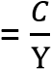
Where:
C = Total consumption expenditure
Y = Total income
Interpretation: If APC = 0.8, it means 80% of income is spent on consumption, and 20% is saved.
- Marginal Propensity to Consume (MPC).
The ratio of change in consumption to change in income.
Formula: MPC=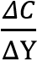
Where:
ΔC = Change in consumption
ΔY = Change in income
Interpretation: If MPC = 0.6, it means that for every extra unit of income earned, 60% is spent on consumption.

Example in Uganda
If a household earns UGX 1,000,000 and spends UGX 800,000 on consumption:
APC = 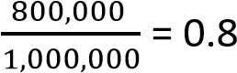
If income rises by UGX 200,000 and consumption rises by UGX 150,000:
MPC 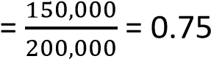
- Marginal propensity to import (MPM). This refers to the fraction (proportion) of additional national income spent on the imports of the country. It is expressed as the ratio of a change in import expenditure to a change in national income
MPM 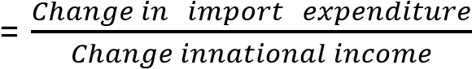
- Average Propensity to import (APM). This refers to the fraction of total national income that isspent on imports. It is expressed as ratio of total expenditure on imports to total national income
AP M= 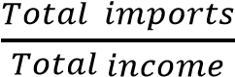

Determinants of (Factors influencing) consumption
- Income Levels: Higher income generally leads to higher consumption, though savings also increase with rising income.
- Wealth: Ownership of assets (land, property, stocks) influences spending—wealthier households consume more.
- Prices of Goods and Services: Rising prices reduce purchasing power, while lower prices encourage consumption.
- Expectations of Future Income: Optimism about future earnings increases current consumption; uncertainty reduces it.
- Interest Rates: High interest rates encourage saving and discourage borrowing for consumption; low rates do the opposite.
- Availability of Credit: Easy access to loans and credit cards boosts consumption, especially for durable goods.
- Social and Cultural Factors: Traditions, peer influence, and lifestyle choices affect spending patterns.
- Government Policies: Taxes, subsidies, and welfare programs directly impact disposable income and consumption.
- Demographics: Age, family size, and education level influence consumption needs and priorities.
- Psychological Factors: Consumer confidence, risk aversion, and preferences shape how much people spend versus save.
- The level of savings. The higher the level of savings, the lower the level of consumption and the lower the level of savings, the higher the level of consumption.
- The level of wages. An increase in the wage rate leads to an increase in consumption and a reduction in the wage level leads to a fall in the level of consumption.
- Size of the population. An increase in population leads to increase in the level of consumption but a fall in population leads to a reduction in the level of consumption.
- Level of Inflation in the economy. An increase in the general price level reduces the real value of money hence a fall in consumption. But a decrease in the general price level increases the real value of money which leads to an increase in income
- Level of retained profits. The more profits the company retains in business the lower the level of consumption while the lower the amount of retained profits the higher the level of consumption

Example in Uganda
- Income Levels: Urban households in Kampala consume more than rural farmers due to higher earnings.
- Prices: Inflation in food staples like maize and beans reduces consumption among low-income families.
- Credit Access: Mobile money loans (e.g., MTN MoMo) increase household spending capacity.
- Government Policies: Subsidies on agricultural inputs encourage rural households to spend more on farming.
- Social Factors: Cultural events like weddings and funerals drive significant spending across communities.

Savings
Savings refer to the part of disposable income that is not spent on the current consumption of goods and services.
Dissaving refers to negative savings. It occurs when consumption is greater than disposable income.

Concepts used under the savings theory
- Contractual savings. These are savings where an individual is supposed to save a fixed amount of money in a given time for example per month. They include savings with insurance companies, pension schemes etc.
- Discretional savings. This is where people are not obliged to save a specific amount in a given time for example bank deposits, building societies etc.
- Marginal propensity to save (MPS). This is the proportion (fraction) of the additional income that is saved. It is expressed as the ratio of change in savings (ΔS) to the change in income (ΔY).
MPS = 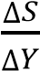
- Average propensity to save (APS) refers to the proportion (fraction) of the total income which is saved. It is expressed as the ratio of total savings to total income.
APS = 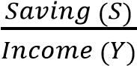

Note: MPC + MPS = 1
Proof
Proof Y = C + S => ΔY = ΔC + ΔYS
Divide through by ΔY
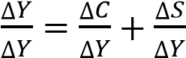
1=MPC + MPS

Determinants of (factors influencing) the Level of savings in the Economy
- Income Levels: Higher incomes generally lead to higher savings, though low-income households may save very little.
- Propensity to Save: Cultural attitudes and personal preferences influence whether people save or spend.
- Interest Rates: Higher interest rates encourage saving by offering better returns, while low rates discourage it.
- Inflation: High inflation erodes the value of savings, discouraging people from saving in cash.
- Availability of Financial Institutions: Access to banks, microfinance, and mobile money platforms makes saving easier and safer.
- Government Policies: Tax incentives, pension schemes, and compulsory savings programs influence national savings levels.
- Demographics: Younger populations tend to save less, while middle-aged and older groups save more for retirement.
- Social Security: Systems Strong welfare systems reduce the need for precautionary savings, while weak systems encourage households to save more.
- Expectations of Future Income: Optimism about future earnings reduces current savings, while uncertainty increases precautionary savings.
- Cultural and Social Norms: In some societies, saving is highly valued, while in others, spending on social events (like weddings or funerals) takes priority.

Example in Uganda
- Income Levels: Rural farmers save little due to subsistence living, while urban professionals save more.
- Financial Institutions: Mobile money platforms (MTN MoMo, Airtel Money) have boosted savings accessibility.
- Government Policies: The National Social Security Fund (NSSF) encourages formal sector workers to save for retirement.
- Inflation: Rising food and fuel prices reduce household ability to save.
- Cultural Norms: Spending on community events often takes precedence over long-term savings.

The investment theory
Investment is the process of devoting part of national income to create capital goods. OR Investment refers to the act of purchasing capital goods and establishing capital assets with the aim of increasing on the level of capital stock in the economy

Net investment: This refers to the total amount of total capital invested minus depreciation (Capital consumption allowance)

Types of investment
- Autonomous investment. This is the form of investment which is independent of the level of income. It is influenced by other factors such as war, climate, population growth, labour force, government policy etc.
- Induced investments. This is the form of investment which depends on the level of income and profits. The higher the level of income, the higher the level of induced investment and the lower the level of income, the lower the level of induced investment.
- Private Investment: Undertaken by individuals or businesses in assets like machinery, buildings, or stocks.
- Public Investment: Government spending on infrastructure, schools, hospitals, and other public goods.
- Foreign Direct Investment (FDI): Investment from foreign companies into domestic industries, often bringing capital and technology.
- Portfolio Investment: Purchase of financial assets like shares and bonds, without direct control over the enterprise.
- Human Capital Investment: Spending on education, training, and healthcare to improve workforce productivity.

Importance of Investment
- Economic Growth: Expands production capacity, increases GDP, and drives long-term development.
- Employment: Creation New industries and businesses generate jobs, reducing unemployment and poverty.
- Technological Advancement: Investment in research and development fosters innovation and efficiency.
- Improved Living Standards: Infrastructure projects (roads, schools, hospitals) enhance quality of life.
- Capital Formation: Savings transformed into investment build the foundation for future production.
- Government Revenue: Expanding industries increase tax bases, funding public services.
- Foreign Exchange Earnings: Investment in export-oriented industries boosts trade and strengthens currency reserves.
- Balanced Regional Development: Directing investment to rural areas reduces inequality and promotes inclusive growth.

Example in Uganda
- Public Investment: Roads, dams, and energy projects funded by government to boost connectivity.
- FDI: Foreign companies investing in coffee processing, telecom, and banking sectors.
- Private Investment: Local entrepreneurs expanding agribusiness and real estate.
- Human Capital: Programs like Universal Primary Education (UPE) improve skills for future productivity.

Factors that determinants of the level of investment i n the Economy
- Rate of Interest: High interest rates discourage borrowing and investment, while low rates encourage it.
- Level of Savings: Higher savings provide more funds for investment through banks and capital markets.
- Expected Returns (Profitability): Businesses invest more when they expect higher profits from new projects.
- Government Policies: Tax incentives, subsidies, and stable regulations encourage investment; heavy taxation or instability discourages it.
- Political Stability: Secure environments attract investors, while instability or corruption reduces confidence.
- Infrastructure Development: Good roads, electricity, and communication systems make investment more attractive.
- Availability of Credit: Access to affordable loans and financial institutions boosts investment.
- Technological Advancement: Innovation creates new opportunities for profitable investment.
- Demand Conditions: Strong consumer demand motivates firms to expand production capacity. (x) Foreign Direct Investment (FDI): External capital inflows increase domestic investment levels.
- Cost of Inputs: High costs of raw materials, labor, or energy discourage investment, while lower costs encourage it.
- Invention and innovation. These normally reduce average cost of production as well as introducing new fashions and products that increase marketability of output. This increases the level of investment
- Population growth; high population provide market and labour required for investment
(xiv)

Example in Uganda
- Government Policies: Tax incentives for agribusiness and industrial parks encourage private investment.
- Infrastructure: Projects like roads and hydroelectric dams attract investors in transport and energy.
- Political Stability: Uganda’s relative stability compared to neighbors has drawn FDI in telecom and banking.
- Savings & Credit Access: Mobile money platforms (MTN MoMo, Airtel Money) expand access to credit, boosting small-scale investment.

The multiplier and accelerator principles

The multiplier
This is the number of times the initial change in a given expenditure multiplies itself to give the final change in income
Multiplier, K =  ………………………………………………………………….. (i)
Where ΔY = change in income, ΔE= change in initial expenditure
From (i)
ΔY = KΔE …………………………………………………………………………….. (ii)
Note. The size of the multiplier depends on the marginal propensity to consume (MPC) and the marginal propensity to save (MPS). Therefore the multiplier can be expressed in terms of MPC and MPS as follows
Multiplier K = 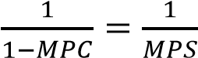

Example 1
Given that in an economy, MPC = 80% and the change in a given expenditure is 200 million.
Calculate
- Size of the multiplier
Multiplier K = 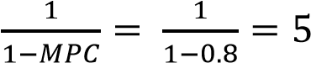times
- Change in final income
Change in income, ΔY = 5 x 200million = 100million

Example 2
Given that a country’s income is 100 million and MPC =0.6.If government expenditure increases from 120m to 600m, calculate the final level of income
Multiplier K = 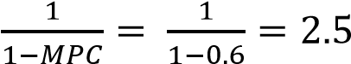times
ΔG = 600m – 120 = 480m
Change in income, ΔY = KΔG = 480 x 2.5 = 1200m

Example to illustrate the operation of the multiplier process in an economy
Suppose the government increases investment expenditure by 1m shillings, assuming that money is invested in an industrial project where MPC = 80% (0.8) and MPS = 20% (0.2), using the table below, the multiplier process can be illustrated to determine how much money is created in the economy as follows.
Time period | ΔY | ΔC(MPC = 0.8) | ΔS (MPS = 0.2)
1 | 1,000,000 | 800,000 | 200,000
2 | 800,000 | 640,000 | 160,000
3 | 6040,000 | 512,000 | 128,000
4 | 512,000 | 409,600 | 102,000
- | - | - | -
- | - | - | -
- | - | - | -
n
Total | 5,000,000 | 4,000,000 | 1,000,000

Multiplier K = times

Money created, ΔY = KΔE = 5 x 1,000,000 = 5,000,000/=

Types of multiplier

- Income multiplier. It refers to the number of times the initial change in total expenditure
(ΔE) multiplies itself to give a final change in income (ΔY)

Income multiplier, K = 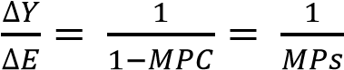
- Consumption multiplier. It refers to the number of times the initial change in consumption expenditure multiplies itself to give the final change in income.
Consumption multiplier = 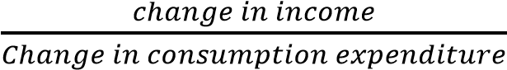
- Investment multiplier. It refers to the number of times the initial change in investment expenditure multiplies i t s e l f to generate a final change in national income
Investment multiplier =
- Government multiplier. It refers to the number of times the initial change in government expenditure multiplies itself to generate a final change in national
income.

Government multiplier = 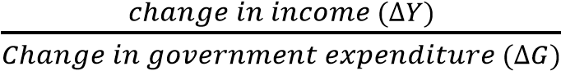
- Tax multiplier. This refers to the number of times the initial change in taxation multiplies itself to generate a final change in national income
Tax multiplier = 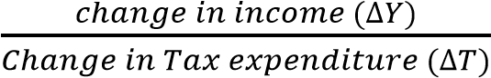
- Export multiplier (Foreign trade multiplier). It refers to the number o f times the initial change in export earnings multiplies itself to generate a final change in national income
Export multiplier = 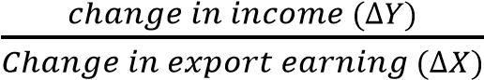
- Import multiplier. It refers to the number o f times the initial change in import expenditure multiplies itself to generate a final change in national income
Import multiplier = 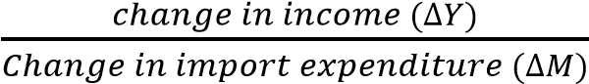

Factors limiting the Multiplier P r o c e s s in Developing Countries
- High Marginal Propensity to Import: A large portion of increased income is spent on imported goods rather than domestic products, reducing local multiplier effects.
- Low Marginal Propensity to Consume: Poor households may prioritize debt repayment or basic needs, limiting additional spending.
- Leakages into Savings: Wealthier groups may save rather than spend, reducing the circulation of income in the economy.
- Unemployment and Underemployment: Idle labor means increased demand does not translate into higher production, weakening the multiplier.
- Poor Infrastructure: Weak transport, energy, and communication systems limit the ability of firms to expand production in response to demand.
- Inflationary Pressures: Increased spending may lead to higher prices instead of higher output, eroding multiplier gains.
- Limited Industrial Base: Heavy reliance on agriculture and raw materials means economies cannot quickly expand production to meet demand.
- Capital Flight: Profits and savings may be invested abroad rather than reinvested locally, reducing domestic multiplier effects.
- Political Instability and Corruption: Mismanagement of resources discourages investment and weakens the spread of income gains.
- Low Human Capital Development: Limited education and skills reduce productivity, preventing effective responses to increased demand.
- High degree of income inequalities. In developing countries, there are few rich people with high marginal propensity to save and low marginal propensity to consume. The majority of the people are low income earners. This reduces the aggregate demand hence low levels of investment.
- Limited resources for investment. In developing countries, there is limited capital and other resources like raw materials necessary for investment and this limits the multiplier process.
- High population growth rates. This results in high dependence burdens and low savings hence low levels investment in developing countries.
- Limited credit facilities for investment. In developing countries, there are few financial institutions and they are concentrated in urban areas. Most people do not have collateral security and therefore cannot access loans from the banks. This leads to low levels of investment.
- Limited entrepreneur skills. In developing countries, there is a limited number of entrepreneurs with the required skills to take on risks and increase investments. This limits the multiplier process.
- Existence of the large subsistence sector in developing countries. There are a limited number of economic activities and this leads to low incomes which cannot support meaningful investments. This limits the multiplier process in developing countries.
- Poor land tenure systems. The system of ownership and use of land is mainly based on individuals and makes it difficult for the government to allocate land to potential investors. This limits investments and the multiplier process in general.

Example in Uganda
- Imports: Rising incomes often lead to higher demand for imported goods like electronics and vehicles, limiting local benefits.
- Infrastructure: Poor rural roads and electricity shortages restrict expansion of agricultural and industrial output.
- Inflation: Food price increases absorb much of the extra income, reducing real multiplier effects.
- Capital Flight: Some foreign investors repatriate profits instead of reinvesting locally.

Accelerator Principle
This e x p l a i n s the relationship between consumption and investment. It states t h a t any change in consumption spending leads to a c h a n g e in investment spending. Therefore; investments are accelerated when there is an increase i n consumption in the short run.
The accelerator refers to the number of times the initial change in consumption(ΔC) multiplies itself to give a final change in induced investment(ΔI).

Accelerator = 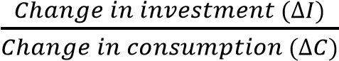
Example 3
In an economy, the increase in consumption of maize from 10,000kg to 20,000kg led to an increase i n investment from 50 million to 100 million. Given that the price per kg of maize is 1000/=, Calculate t h e accelerator

Solution
ΔC = (20,000 – 10,000) x 1000 = 10,000,000/=
ΔI = 100,000,000 – 50, 000,000 = 50,000,000/=

Accelerator =

Assumptions of the Accelerator principle
- There is full employment of resources
- The change in consumption is permanent such at the producers are confident to invest in more capital
- It assumes that producers have no foresight to forecast for increased consumption
- It assumes a closed economy

Limitations of the Accelerator Principle
- Assumption of Constant Capital-Output Ratio: The principle assumes a fixed relationship between capital and output, but in reality, technology and efficiency can change this ratio.
- Neglect of Time Lags: Investment does not respond instantly to changes in demand; delays in planning, financing, and construction weaken the accelerator effect.
- Ignores Other Determinants of Investment: Factors like interest rates, government policy, and business confidence also influence investment, not just demand changes.
- Instability in Business Cycles: The accelerator can exaggerate booms and busts, leading to economic instability rather than smooth growth.
- Assumption of Full Capacity Utilization: It presumes firms always operate at full capacity, but in reality, idle resources may absorb demand increases without new investment.
- Neglect of Expectations: Future demand expectations, risk perception, and investor confidence play a major role, which the accelerator principle overlooks.
- Limited Applicability in Developing Countries: Weak infrastructure, low savings, and reliance on imports reduce the responsiveness of investment to demand changes.
- Capital Constraints: Even if demand rises, firms in developing economies may lack access to credit or capital to invest.
- The principle ignores the possibility of importing goods and services from other countries to meet the increased consumption without increasing i n v e s t m e n t .
Example in Uganda
- Time Lags: Rising demand for coffee exports does not immediately lead to new processing plants due to financing delays.
- Capital Constraints: Small-scale farmers may see higher demand but lack credit to expand production.
- Infrastructure Gaps: Poor transport and electricity limit the ability of firms to respond to demand increases.

Macroeconomic equilibrium and disequilibrium macroeconomic equilibrium
The economy is in equilibrium when there is no tendency for the macroeconomic forces to change.
There are two methods of determining equilibrium national income
- Aggregate demand-Aggregate supply approach (Keynesian approach)
- Leakages - injections approach (Classical approach)

(a) Aggregate demand - Aggregate supply approach (Keynesian Approach)

- In this case, equilibrium of the economy is determined at a point where aggregate demand equals to aggregate supply at full employment level of resources.
- Aggregate demand is the amount of all goods and services required by all sectors in the economy in a given time. That is the consumers, business sectors, government and the foreign sector.
- Aggregate supply is the total amount of output that all sectors of the economy are willing and able to produce and sell in a given time.
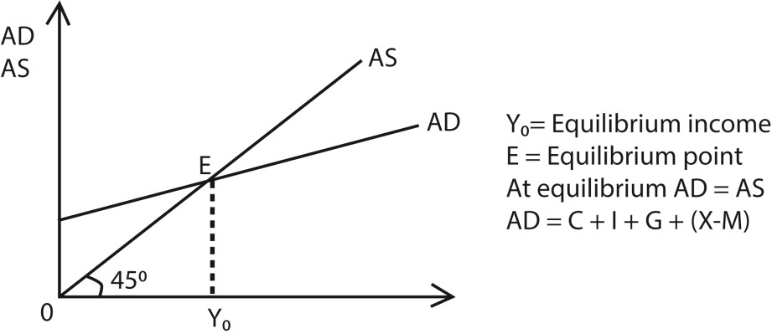

(b) Leakages - injections approach (Classical approach)

In this case, equilibrium income is determined at a point where leakages are equal to injections in the economy. That is Injections = Leakages.
- Injections(Additions). These are items (elements) which increase the level of circular flow of income. OR Injections are the additions to the circular flow of income. They lead to an increase in the amount of money flowing in the circular flow of income. Examples of injections include export earnings(X), investments (I) and government expenditure (G)
.
- Leakages (Withdrawals). These are items (elements) which reduce the level of circular flow of income. OR. Leakages are subtractions from the circular flow of income. They lead to decrease in the amount of money flowing in the circular flow of income. Examples o f leakages include savings(S), import expenditure (M) and taxes (T).

Macro- economic disequilibrium

According to Lord Keynes the economy is in dis-equilibrium when aggregate demand is not equal to aggregate supply. This gives rise to either the Deflationary gap or Inflationary gap.

Deflationary gap
Deflationary gap is the amount by which aggregate supply exceed aggregate demand at level of full employment. As shown in the figure below deflationary gap is a measure of amount of deficiency of aggregate demand.
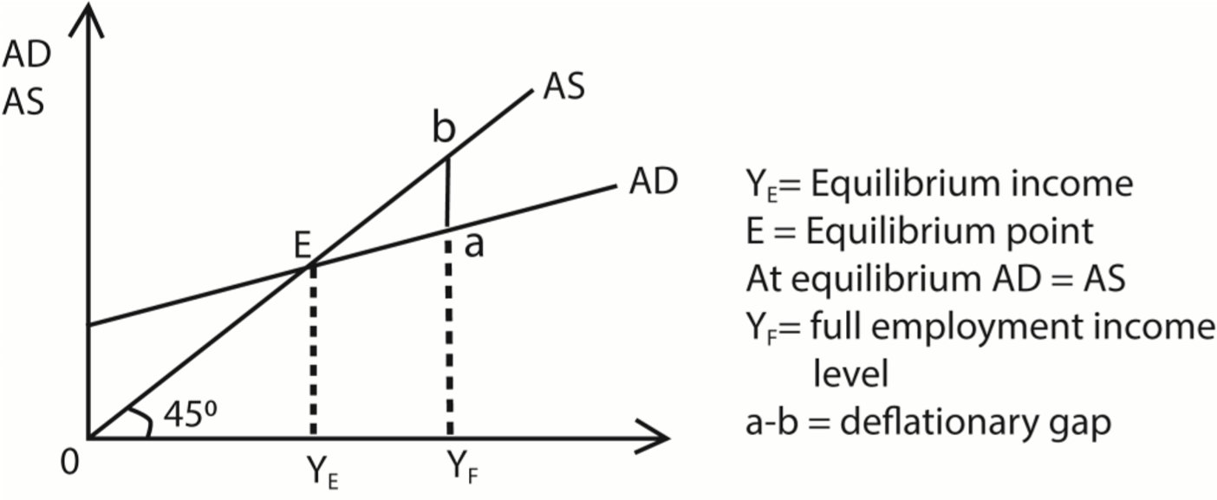
The diagram above shows that the bigger the deflationary gap, the bigger the difference between the level of ‘full employment’ Y_{f} and real output (Y_{E}).

In other words, a deflationary gap shows the amount by which aggregate demand must be increased so that equilibrium level of income is increased to the full employment level. Causes of Deflationary Gap
- Fall in consumer spending: due to low wages, high interest rates, or pessimism.
- Decline in investment: caused by credit crunch, high borrowing costs, or weak business confidence.
- Reduced exports: global recessions or falling demand for domestic goods abroad.
- Government austerity: reduced public spending lowers aggregate demand.
- Underutilized resources: idle labor and capital mean the economy operates below capacity.

Consequences
- High unemployment: firms cut jobs due to low demand.
- Low economic growth: GDP stagnates below potential.
- Falling prices (deflation): weak demand pressures prices downward.
- Wasted resources: factories, land, and labor remain idle.
- Lower living standards: reduced incomes and consumption.

Example in Uganda
- During a global downturn, demand for coffee exports may fall.
- Farmers produce less, factories reduce output, and unemployment rises.
- The gap between Uganda’s potential GDP (if all resources were fully used) and its actual GDP widens—this is the deflationary gap.

Measures (Policies) to eliminate the deflationary gap Increase demand or reduce supply through:
- Expansionary Fiscal Policy o Reduce personal income taxes to increase disposable income and encourage spending. o Increase government expenditure on infrastructure, education, and health to inject money into the economy.
  - Provide subsidies to industries and farmers to lower costs and stimulate production.
- Expansionary Monetary Policy o Lower interest rates to encourage borrowing for consumption and investment.
  - Increase money supply through central bank operations, making credit more available.
- Wage and Employment Policies o Raise wages to boost purchasing power.
  - Support trade unions in negotiating better pay, which increases aggregate demand.
- External Sector Policies o Promote tourism and attract immigrants to increase spending in the economy.
  - Encourage exports by reducing trade barriers and supporting local industries.
- Confidence-Building Measures o Stabilize political and economic conditions to encourage private investment.
  - Provide incentives for businesses to expand production.
- Encourage subsidies, the consumer can be offered subsidies to increase their levels of consumption thereby increasing aggregate demand.
- Improvement in the infrastructure for example transport network to ease movement of surpluses through arbitrage
Example in Uganda
- Fiscal Policy: The government can increase spending on rural roads and electricity projects to stimulate demand.
- Monetary Policy: The Bank of Uganda can lower interest rates to encourage borrowing by farmers and entrepreneurs.
- Wage Policies: Raising salaries for teachers and health workers increases household consumption.
- External Sector: Promoting Uganda’s tourism (e.g., gorilla trekking) attracts foreign spending, boosting aggregate demand.

Inflationary (negative output) gap
Inflationary gap is the amount by which aggregate demand exceed aggregate supply at level of full employment. As shown in the figure below Inflationary gap is a measure of amount of deficiency of aggregate supply.
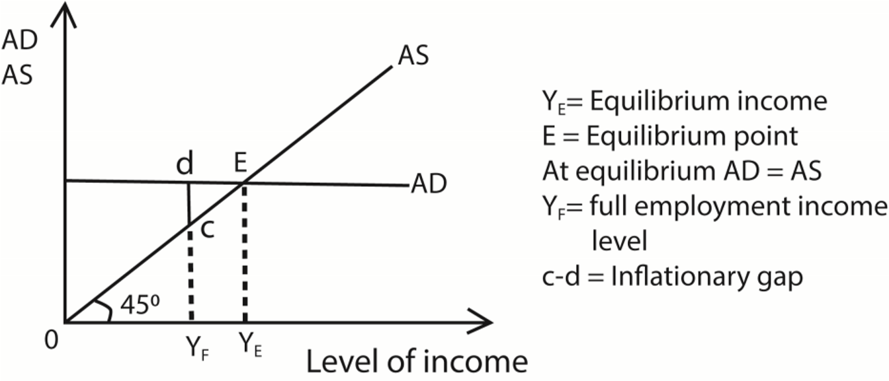

- The diagram above shows that the bigger the inflationary gap, the smaller the level of national income since income increases from Y_{f} to Y_{E}.
- Inflationary gap causes a rise in price level which is called inflation and leads to an increase in employment and income.

Measures (policies) to eliminate the inflationary gap
Decrease aggregate demand or increase supply through
- Monetary policy – raising interest rates
  - Increases borrowing costs, discourages consumer spending and business investment. o Slows down aggregate demand, reducing inflationary pressures.
- Tight fiscal policy – higher taxes or reduced government spending
  - Higher taxes reduce disposable income, lowering consumption. o Cutting government spending directly reduces demand in the economy.
- Reducing budget deficits or creating surpluses
  - Governments may run a fiscal surplus to absorb excess demand. o Helps stabilize long-term inflation expectations.
- Supply-side policies o Improve productivity and efficiency (e.g., investment in technology, deregulation).
  - Expands potential output, narrowing the gap between actual and potential GDP. o Discourage the exportation of goods and services which are scarce in the economy
- Wage and price controls
  - Temporary measures to prevent wage-price spirals. o Often used in extreme cases but can distort markets if prolonged.
- Exchange rate appreciation
  - A stronger currency makes imports cheaper, reducing inflationary pressures. o However, it can hurt exports and growth.

Trade-offs and Risks
- Higher interest rates may reduce inflation but risk slowing growth and increasing unemployment.
- Tax increases or spending cuts can be politically unpopular and may disproportionately affect lower-income households.
- Supply-side reforms take longer to show results compared to monetary/fiscal tightening.
- Wage/price controls can cause shortages or black markets if maintained too long.

Price indices
Price index refers to a figure which measures the relative changes in the prices of goods and services from one period which is usually the base year to another period which is the current year.
The magnitude of the percentage change in the price of commodities from the base year to the current year indicates a fall or a rise in the cost of living.

Types of Price Indices

Consumer Price Index (CPI). This is a figure which measures the relative changes in the prices of consumer goods and services used by people. It indicates t h e real value of money between t h e base year and the current year.

Cost of Living Index (CLl). This is a figure which measures the relative c h a n g e s i n the prices of the basic needs of people from the base year to the current year. The percentage change in the prices of basic needs of people between the base year and the current year gives a change in the cost of living.

GNP Index (GNP Deflator). This is a figure that is used to convert the nominal GNP at current market price to real GNP at a base year
GNP Deflator = 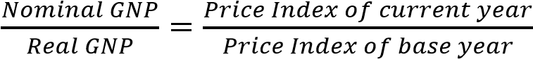
But Price Index of base year = 100
⇨ 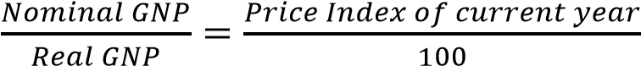
Thus Real GNP = 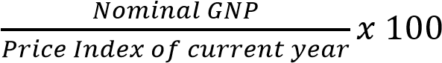

Example 4
Suppose the GNP was 120billion shillings and price index for 2019 was 200. Taking 2012 as the base year, determine the real GNP 2019.

Thus Real GNP for 2019 = 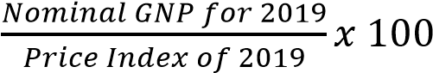
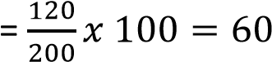billions shillings

Concepts of Price index
- Price R e l a tiv e s (PR). This is a figure which measures the relative changes in the prices of a single commodity between the base year and the current year. It is referred t o as the price relative because it relates the prices of the same commodity between the two periods.
- Base Year. This refers to the year in which prices were stable as compared t o other years. The base year is given an index of 100 which is used as a reference figure to indicate whether there has been a fall or rise in the price of a particular
commodity.

Price Relative (PR) = 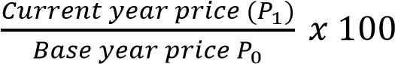
- Simple Price Index (Average Price Relative). This is a figure which measures the relative changes in the prices for a number of commodities between the base year and the current year.
Simple Price Index (Average Price Relative) =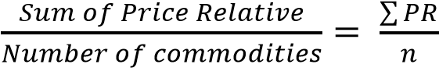

- Weighted Price Index. This refers to the product of the price relatives and the weights attached to the commodities indicating their degrees of importance. The weights can be in terms of the quantities of the commodities consumed, values of items consumed or figures attached to commodities.

Weighted Price Index = Price Relatives x Weights
It is noted that simple price indices (average price relatives) do not tell us much about the relative importance the consumer attaches to the commodities. Therefore weights are used under weighted price indices to indicate the relative importance the consumer attaches on the various commodities (basket of goods) consumed.

- Average Weighted Index. This is the ratio of the sum of the weighted indices to the sum of the weights. It is given by the formula;
Average Weighted Index = 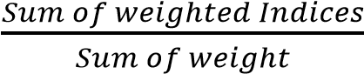
Procedure for Computing Price Indices
- Define the objectives of calculating the price index e.g. wage determination.
- Choose an area where the data is to be collected
- Get the price for each good in a basket ( A basket of commodities are a sample of goods consumed by most people)
- Choose a base year (a year when prices were relatively stable)
- Simple index of the base year should be given unit 100
- Attach weights to each good in the basket
- Obtain prices in the current year
A hypothetical table is shown below
Commodity | Base year prices | Base year simple index | Current year prices (4years later) | weight
A  B  C  D  E | 200  150  500  100  700 | 100  100  100  100  100 | 700  500  1000  300  1200 | 5  4  3  2  1
Simple calculation/illustration
Simple price index (PR) = 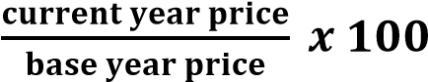
For A: 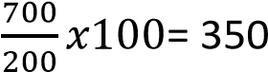
For B: 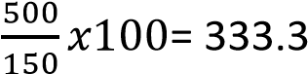
For C: (1000/500) x 100 = 200
For D: 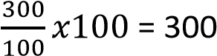
For E: 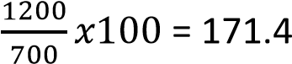
Average simple price index = 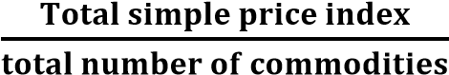
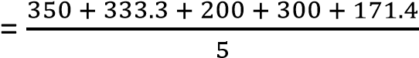
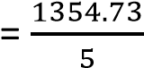
= 271
Weighted price index = simple price x weight
A: 350 x 5 = 1750
B: 333.3 x 4 = 1333.2
C: 200 x3 = 600
D: 300 x 2 = 600
E: 171.4 x 1 = 171.4
Average weighted price index = 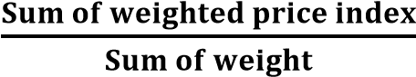
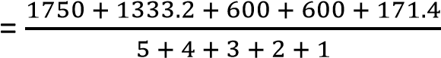
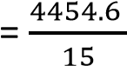
= 297
Conclusion
There was overall increase in general price level by 297% Importance (Uses) of Price Indices
- Measuring inflation: Price indices (like CPI or PPI) show how fast prices are rising, helping policymakers and businesses monitor inflationary trends.
- Deflating nominal values to real terms: They allow conversion of nominal GDP into real GDP, giving a clearer picture of economic growth without the distortion of inflation.
- Adjusting wages, pensions, and contracts: Many countries use indexation (linking payments to price indices) to protect incomes from inflation.
- Analyzing purchasing power: Price indices reveal how much consumers can buy with their income, showing changes in living standards.
- Guiding monetary and fiscal policy: Central banks rely on price indices to decide interest rates, while governments use them to plan spending and taxation.
- International trade comparisons: Price indices help compare competitiveness across countries by adjusting for inflation and exchange rate effects.
- Business forecasting and planning: Firms use price indices to anticipate cost changes, set prices, and plan production.
- Labor market analysis: They help assess real wage trends and the impact of inflation on employment contracts.
- They are used to adjust nominal GNP to real GNP using the GNP deflator
- Price indices are used to measure the rate of economic growth of the country over time.
This is achieved by computing the GNP/GDP indices
Limitations to Keep in Mind
- Sampling bias: Indices may not capture all goods/services.
- Regional differences: National indices may not reflect local price changes.
- Quality changes: Adjusting for improvements in products is complex.
- Time lag: Indices are often published with delays, limiting real-time accuracy.

Problems encountered when compiling price Indices
- Choice of base year: The base year must be free from abnormal conditions (wars, famines, political instability). If chosen poorly, comparisons become misleading.
- Selection of commodities: The basket must reflect the tastes, habits, and customs of the population. Excluding key items or including irrelevant ones leads to bias.
- Quality changes in goods: Adjusting for improvements or deterioration in product quality is complex. Without proper adjustment, indices may overstate or understate inflation.
- Choice of weights: Different goods contribute unequally to consumer spending. Assigning appropriate weights is difficult, especially when consumption patterns change.
- Inadequate coverage: It is impossible to cover all commodities and regions. Limited sampling may produce unrepresentative results.
- Income variation: Different income groups consume different baskets of goods. A single index may not reflect inflation experienced by all households.
- Time factor: Prices change continuously, but indices are often compiled monthly or quarterly. This lag reduces accuracy.
- Comparability across countries: Different methods and baskets make international comparisons difficult. Cultural and consumption differences further complicate this.
- Difficult in choosing the representative families, from where necessary data has to be collected.
- Inadequate skilled labour to collect information (xi) Wrong information from interviewee.
(xii) Price discrimination may make it difficult to choose a price of a commodity.
Business (trade) cycles
- An economy usually experiences fluctuations and these fluctuations are the upward and downward movements of various economic variables which also lead to fluctuations in output. Therefore, in practice, aggregate output (GNP) does not grow smoothly. At certain times it grows rapidly and at other times it falls.
.
- Actual output fluctuates around the trend path. A trend path is a long run smooth path which is traced out in the long run after a averaging out the short run fluctuations in GNP (output). The short run fluctuations in output are referred to as Trade (Business) cycles. There are four stages of business cycles as illustrated below
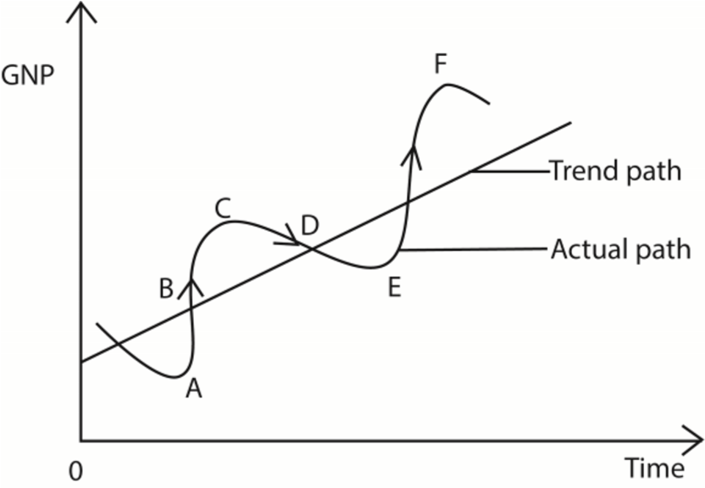

- Points A and E are called T r o ugh (slump). A trough is an economic period during which all economic activities are at their lowest levels For example consumption, investment, prices, employment etc. It is the lowest p o r t i o n of the recession.
- Point D is caned a Depression (Recession). It is an economic period during
which all economic activities such as production, employment; investments, aggregate demand, savings, prices etc. are rapidly falling.
- Point B is called a Recovery .It is an economic period during which all economic activities such as production, employment, investments, aggregate demand, savings, prices etc. are rapidly increasing.
- Points C and Fare called Boom (Peak). It is an economic period during which all economic activities such as production, employment, investments, aggregate demand, savings, prices etc. are at their highest levels. It is the highest portion of the recovery

Revision questions

Section A questions

- (a) Define the term consumption.
(b) Mention three determinants of the level of consumption in your country.
- (a) Distinguish between the investment multiplier and government multiplier
(b) Given that in an economy, MPS = 40%. Calculate t h e value of the multiplier
3 (a) Distinguish between autonomous investment and induced investment
(b) Mention two reasons as to why education i s regarded as an investment 4 (a) Distinguish between Marginal propensity to save and average propensity to consume
(b) Give two determinants of marginal propensity to save in your country.
5 (a) Distinguish between Marginal Propensity to Consume and Average Propensity to Consume.
(b) Given that the Marginal P r o p e n s i t y to Consume i s 80%. Calculate the value of the multiplier.
6 (a) Define the term "multiplier"
(b) Given that investment expenditure rose form shs. 15,500,000,000/= to 19,250,000,000/= in an economy with marginal propensity to consume o f
0.4, calculate the change in income.
7 (a) Distinguish between marginal propensity to consume and average propensity to consume.
(b) Calculate the final change in the level of income given that the initial change in investment is
20,000/= and MPC = 80%.
8 (a) Distinguish between “injections" and leakages as used in economics
(b) Give two injections t o the circular flow of income
- (a) Distinguish between a "negative o u t p u t gap” and a "positive output gap"
  - State two demerits of a negative output gap in an economy.
- Distinguish between the following concepts
  - Marginal propensity to import and marginal propensity to export.
  - A closed economy and an open economy.
11(a) Distinguish between aggregate demand and aggregate supply
  - Mention two determinants of aggregate supply in your country
- (a) What is meant by price index
  - Mention three uses of price indices in an economy
- (a) Define the term "marginal propensity to consume"
  - Given that a country's national income is U g Shs 100 million, the marginal propensity to consume is 0.6. Calculate the country’s final level of income
- (a) What is meant by accelerator principal? .
  - Give three limitations of the accelerator principle in your country

Section B questions

- (a) Distinguish between a Deflationary gap and an inflationary gap (b) Explain the policies which can be used to close;
(i) Deflationary gap ii). Inflationary gap
- (a) Distinguish between consumption multiplier and export multiplier
(b) Examine the factors which influence the operation of the investment multiplier in your country,
- (a) Study the table below showing commodity prices for selected items (in 2008 and
2010) and answer the questions that follow

Commodit  y | Prices in 2008 | Simple Index | Prices in 2010 | Weights
A | 200 | 100 | 700 | 2
B | 150 | 100 | 500 | 3
C | 500 | 100 | 1000 | 4
D | 100 | 100 | 300 | 6
E | 700 | 100 | 1200 | 1
.
Calculate the;
    - Simple price index for each commodity in 2010.
    - Simple index for 2010
    - Weighted price index for each commodity in 2010.
(iii) Average weighted price index for 2010
  - Explain the problems faced in the computation of price indices in your country.
  - Explain the importance of compiling price indices in an economy.
- (a) Distinguish between savings and investment
  - Examine the determinants of investment in your country. 5 (a) Explain how the cost-of-living indices are computed
(b) What are the limitations of using the cost-of-living indices as a measure of welfare over time?
6 (a) What are business (trade) cycles? Distinguish between a depression and a recovery phase of the trade cycle
(b) Explain the policies that can be used to lift the economy out of a depression

TOPIC 2/2: Economic Growth, Economic Development and Development Theories
Competency: The learner analyses and applies growth theories to develop evidence-based recommendations for community stakeholders and policymakers, promoting informed decision-making for sustainable economic growth and national development.

Economic growth
Economic growth is the sustained persistent quantitative increase in the country’s volume of goods and services as measured by an increase in Gross National Product (GNP) in a given period of time usually a year compared with the previous period.

Determinants of (factors affecting) economic growth
- Capital accumulation: Investment in machinery, infrastructure, and factories increases productive capacity. More capital per worker raises output and efficiency.
- Labor force growth: A larger workforce contributes to higher output. Productivity depends on skills, health, and motivation of workers.
- Technological progress: Innovation and adoption of new technologies boost efficiency.
Examples: automation, digitalization, renewable energy.
- Human capital development: Education, training, and healthcare improve worker productivity. Skilled labor adapts better to new technologies.
- Natural resources: Availability of land, minerals, and energy supports growth. Sustainable use is crucial to avoid depletion.
- Institutional quality: Strong governance, rule of law, and property rights encourage investment. Corruption and instability hinder growth.
- Trade and openness: Access to global markets fosters specialization and efficiency.
Foreign investment brings capital and technology.
- Public expenditure and infrastructure: Government spending on roads, energy, and communication supports private sector growth. Efficient infrastructure reduces transaction costs.
- Increase in the number and quality of entrepreneurs. Presence of individuals who have the ability to organize and mobilize other factors of production leads to an increase in production hence economic growth and absence of such individuals discourages production hence low levels of economic growth.
- Availability of market including local and foreign market. The large market encourages investments which lead to the production of more goods and services hence economic growth. But a narrow market discourages investment and production hence low levels of economic growth.
- Ideal population growth to provide labour and market
- Political stability. Political stability encourages investment and lead to economic growth (xiii) Appropriate planning and effective implementation of economic programs.
- Level of investment. High level of investment in an economy increases the production of goods and services.
- The level of monetization of the economy. The higher the level of monetization of the economy, the higher the level of economic growth, But a large subsistence sector discourages production and exchange hence low levels of economic growth.
- The degree of specialization and division of labour in production. The high degree of specialization in the economy leads to economies of large scale production hence economic growth and the low degree of specialization discourages large scale production hence low level of economic growth.

Benefits (advantages) of economic growth
- Higher living standards: Growth raises per capita income, allowing people to afford better housing, healthcare, and education.
- More employment opportunities: Expanding industries and services create jobs, reducing unemployment and poverty.
- Increased government revenue: Higher incomes and profits generate more tax revenue, enabling governments to invest in infrastructure and welfare.
- Improved social services: With more resources, governments can expand healthcare, education, and social protection programs.
- Investment in technology and innovation: Growth encourages research and development, leading to productivity gains and new industries.
- Reduction in poverty: Sustained growth lifts people out of poverty by raising incomes and expanding opportunities.
- Better international competitiveness: A growing economy attracts foreign investment and strengthens trade performance.
- Infrastructure development: Roads, energy, and communication systems improve, supporting both businesses and households.
- Fiscal sustainability: Strong growth reduces reliance on borrowing and helps governments manage debt more effectively.
- It leads to a fall in the general price level of goods and services hence improving the standards of living of the people. As the economy grows, a variety of goods and services are produced and this results into a fall in the general price levels hence an increase in the volume of commodities consumed.
- It improves the balance of payment position of the country. As the economy grows the production of goods and services for both the domestic market and for exports increases. This helps the country to save and earn foreign exchange hence better balance of payment position.
- It leads to an increase in employment opportunities. This is in form of increased resource utilization and other economic activities set up. This increases the income of the people.
- It reduces the dependence of the economy on other economies. As the economy grows, per capita income raises and this leads to an increase in self-reliance and sustenance of the economy.
- It reduces income inequalities in the economy. As the economy grows, it is possible for the government to redistribute part of the increased employment opportunities and income through the use of appropriate government policies like progressive taxation.
Costs (demerits) of economic gro w th
- Environmental degradation: Rapid industrialization leads to pollution, deforestation, and depletion of natural resources. Climate change risks increase with unchecked growth.
- Income inequality: Growth often benefits the wealthy more than the poor. Widening gaps can cause social unrest and reduce inclusivity.
- Inflationary pressures: Fast growth can create demand-pull inflation, raising the cost of living. Poor households are hit hardest by rising prices.
- Overexploitation of resources: Non-renewable resources may be depleted, threatening long-term sustainability.
- Urbanization problems: Rapid growth drives migration to cities, causing congestion, slums, and inadequate infrastructure.
- Social and cultural disruption: Traditional lifestyles may be eroded by modernization. Communities face stress from rapid change.
- External dependence: Growth driven by foreign investment or exports can make economies vulnerable to global shocks.
- Health and stress issues: High-paced economic activity can increase work-related stress and reduce quality of life.
- Technological unemployment. As the economy grows, there is increased use of capital intensive techniques of production which in the long run replaces labour hence technological unemployment.
- Profit repatriation. This is true if production is dominated by Foreign Direct Investments.
- Loss of craftsmanship. The increased dependence on the use of machines like computers and other capital equipments leads to loss of natural creativity in the long run.

Economic development
Economic development is a multidimensional process involving sustained increases in income, reduction of poverty, and improvements in health, education, and living standards.
Difference from economic growth: Growth is quantitative (increase in GDP), while development is qualitative (improvement in welfare).
Structural transformation: Development often involves shifting from agriculture to industry and services, accompanied by technological progress.
Key Features of Economic Development
- Improved living standards: Better housing, healthcare, and education.
- Reduction in poverty: Expanding opportunities for marginalized groups.
- Human capital development: Investment in education and training.
- Infrastructure expansion: Roads, electricity, and communication systems.
- Institutional quality: Strong governance, rule of law, and political stability.
- Technological advancement: Innovation and adoption of modern production methods.
Economic Growth vs. Economic Development
Aspect | Economic Growth | Economic Development
Focus | Increase in GDP | Improvement in welfare
Measure | Output, income | Health, education, poverty reduction
Timeframe | Short/medium term | Long-term, structural
Nature | Quantitative | Qualitative

Importance of Economic Development
- Improves living standards: Provides better housing, healthcare, education, and nutrition. Enhances overall quality of life for citizens.
- Reduces poverty and inequality: Expands opportunities for marginalized groups and Ensures more equitable distribution of resources.
- Promotes human capital development: Investment in education and skills increases productivity. A healthier, more skilled workforce drives innovation.
- Strengthens institutions and governance: Development fosters political stability, rule of law, and accountability. Encourages investment and reduces corruption.
- Supports infrastructure growth: Roads, electricity, and communication systems improve efficiency; which facilitates trade and industrialization.
- Encourages technological progress: Development stimulates innovation and adoption of modern technology. This boosts competitiveness in global markets.
- Enhances resilience to shocks: Economies with strong development withstand crises better and reduces vulnerability to external factors like commodity price swings.
- Promotes sustainability: Balances economic growth with environmental protection and ensures resources are preserved for future generations.
Circumstances leading to economic growth without economic development
- Resource-based growth: Heavy reliance on exports of oil, minerals, or cash crops can boost GDP where wealth concentrate in elites, leaving poverty and inequality unchanged.
- Unequal income distribution: Growth benefits the rich disproportionately while poor households see little improvement in living standards.
- Jobless growth: GDP rises due to automation or capital-intensive industries while employment opportunities stagnate, leaving unemployment high.
- Environmental degradation: Growth achieved by exploiting forests, fisheries, or fossil fuels while long-term sustainability and health deteriorate.
- Weak institutions and corruption: Mismanagement of public funds prevents investment in education, healthcare, and infrastructure. Growth does not translate into social progress.
- External dependence: Growth driven by foreign investment or aid may not build local capacity because profits are repatriated abroad, limiting domestic development.
- Neglect of human capital: Growth focuses on physical capital but ignores education and healthcare. Consequently, productivity gains are not shared widely.
- Inflationary growth: GDP rises nominally due to price increases rather than real output while living standards remain stagnant.
- When there are high levels of traditionalism and conservatism which negatively affect peoples’ attitude towards development.
- When the fundamental human rights like freedom of worship, expression, speech are abused by the government authorities.
- When people are over working at the expense of leisure in order to produce more goods and services.
- When there is high degree of political instabilities in the country such that the increased GDP and per capita income realized in an economy are due to increased military expenditure rather than expenditure on social services.

Under development
Underdevelopment is a state in which an economy fails to provide adequate living conditions, opportunities, and growth for its population.

Characteristics of underdeveloped Countries
- Low per capita income: Majority of the population lives below poverty lines.
- High unemployment and underemployment: Many people lack jobs or work in lowproductivity sectors.
- Poor infrastructure: Limited access to roads, electricity, clean water, and communication.
- Low literacy and education levels: Weak human capital reduces productivity and innovation.
- Weak institutions: Corruption, poor governance, and lack of rule of law.
- Dependence on primary products: Economies rely heavily on agriculture or raw material exports.
- High population growth: Strains resources and slows improvements in living standards. (viii) Poor healthcare: High infant mortality, low life expectancy, and widespread diseases.
- Low levels of labour productivity. Under developed countries are characterized by low levels of labour productivity due to absence or inadequate co-operant factor inputs such as capital, better technology and low levels of education and skills.
- Persistent capital outflow due to importation of luxurious items to match the developed country style
- High corruption and embezzlement of funds by government official
- Technology backwardness
.This is due to limited capital for research; innovations and inventions necessary for technological progress. Technology backwardness is reflected in low labour productivity and production of poor quality goods and services.
- High levels of conservatism and traditionalism. Most people in developing countries believe in cultural norms and they are deeply rooted in cultural beliefs to the extent that they cannot allow positive reforms necessary for development to take place.
- Existence of excess capacity. There is underutilization of natural resources in most sectors of developing economies due to inadequate capital, use of poor technology, limited markets and poor management and entrepreneurial skills. This leads to low economic growth rate.
- High levels of political instability. This is due to greed for power and bad leadership by leaders of developing countries.
- Brain drainage due to increasing unemployment and poor working conditions
Causes of underdevelopment in developing countries
- Colonial legacy: Many economies were structured around resource extraction during colonial rule. Artificial borders and exploitative institutions left lasting structural weaknesses.
- Weak institutions and governance: Corruption, lack of accountability, and poor rule of law discourage investment. Political instability undermines long-term planning.
- Poor infrastructure: Inadequate roads, electricity, and communication systems limit productivity and trade. Rural areas remain disconnected from economic opportunities.
- Low investment in human capital: Limited access to quality education and healthcare reduces workforce productivity. High illiteracy and poor health outcomes perpetuate poverty.
- Dependence on primary products: Heavy reliance on agriculture or raw material exports makes economies vulnerable to price fluctuations. Lack of diversification hinders industrialization.
- Rapid population growth: High fertility rates strain resources and social services. This creates pressure on employment and infrastructure.
- External dependence: Reliance on foreign aid or investment without building domestic capacity. Profits often repatriated abroad, limiting local development.
- Social and cultural factors: Traditional practices, gender inequality, and resistance to change can slow modernization. Limits participation of all groups in economic progress.
- Low levels of technology. Most developing countries use traditional, out dated and inefficient technology. This leads to resource underutilization and production of low output and ·of poor quality hence under development.
- Limited capital. This is due to low levels of incomes and limited access to credit facilities from financial institutions due to lack of collateral securities. This limits the expansion of business opportunities in developing countries.
- Limited markets for the products. This is due to low aggregate demand resulting from high levels of poverty in developing countries.
- Rampant political instabilities in developing countries. These are manifested in form of wars and political sabotage which discourage investments and other income generating activities hence under development.
- Poor land tenure systems in developing countries. In developing countries, the system of land ownership and use is poor. Many people do not own land and therefore, they cannot use it to effectively use it to carry out large scale production hence underdevelopment
- Occurrence of unfavorable natural factors like draught, heavy destructive rains, pests and diseases all of which limit investments in the agricultural sector hence under development.
- Persistent huge external public debts. This leads to capital outflow in form of debt servicing through the repayment of the interest and principle on the external public debts.
- High levels of brain drain. Developing countries persistently lose highly skilled man power to developed countries in search for 'greener pastures' in form of good working conditions and high pay. This leads to depletion of skilled human resource in developing countries hence under development.
- High levels of profit repatriation in developing countries. This is due to the presence of multinational co operations in developing countries. This limits capital accumulation in developing countries hence underdevelopment.
Policy Measures to reduce under development i n developing c o u n t r i e s
- Investment in education and skills: Expand access to quality education and vocational training. Build human capital to increase productivity and innovation.
- Healthcare improvements: Strengthen public health systems to reduce disease burden.
Improve nutrition and maternal/child health for a healthier workforce.
- Infrastructure development: Invest in roads, electricity, clean water, and digital connectivity. Reduce transaction costs and link rural areas to markets.
- Economic diversification: Reduce dependence on primary products (e.g., agriculture, minerals). Promote industrialization and service sector growth.
- Good governance and institutions: Fight corruption, strengthen rule of law, and ensure accountability. Create a stable environment for investment and development.
- Population management: Promote family planning and awareness to balance population growth with resources.
- Encouraging foreign direct investment (FDI): Attract responsible FDI to bring capital, technology, and jobs. But ensure policies prevent exploitation and promote local linkages.
- Trade openness and regional integration: Expand access to global markets and strengthen regional trade blocs for collective growth.
- Agricultural modernization: Invest in irrigation, mechanization, and storage facilities to increase food security and rural incomes.
- Sustainable resource management: Prevent overexploitation of forests, minerals, and fisheries. Balance growth with environmental protection.
- Provide affordable credit facilities by the government. Microfinance institutions as well as credit and savings societies should be encouraged to ensure easy access to cheap credit. Improvement in the level of technology. Adopt modern technology to increase productivity.
- Privatization of inefficient enterprises to improve efficiency
- Ensuring political stability. This helps to promote a favorable atmosphere for investments.
- Promote industrialization to create employment opportunities
- Land reform policies. These should be aimed at improving the existing land tenure system through and redistribution, leasing, consolidation and resettlement. All this is aimed at improving the productivity and use of land. "
Rostov's theory of economic growth
Rostov's theory of economic growth describes the stages of economic growth in a historical perspective. According to W.W. Rostov, economies inevitably pass through a series of distinct stages of economic growth through which they are transformed from subsistence traditional and stagnant low per capita income state to the advanced modern and industrialized state. Rostov distinguishes five successive stages of economic growth through which an economy passes to achieve economic development, with
accumulated savings and capital as the driving force. These stages include;
- The traditional stage (Subsistence stage)
- The Pre-condition for take-off (Transition) stage
- The take-off stage
- The drive to maturity stage
- The maturity stage (Age of high mass consumption)

The traditional (subsistence) stage
This is the first stage of economic growth according to Rostov. It is characterized by the following;
- There is great use of primitive tools of production (traditional backward technology). Traditional methods of production are dominant. For example use of rudimentary tools like hoes, pangas, slashes etc.
- The society is communal. Wealth is collectively owned. Family and clan connections play a dominant role in the social structure of societies.
- There is no savings hence unnoticeable capital accumulation due to subsistence production.
- Existence of high levels of conservatism and traditionalism. Traditional beliefs and values dominate societies and these hinder socio-economic transformation.
S. It is dominated by the traditional subsistence sector. People mainly produce for

their own consumption rather than for the market.
- The economy is a closed. There is no international trade to influence economic activities in the economy.
- There are high levels of illiteracy and ignorance among the population due to low levels of education
- Barter trade is the main system of exchange with hardly any monetary exchange-taking place.
- The economy is generally static with high levels of poverty and virtually no growth.
- People are not profit motivated and there is minimal competition between in the production process.

The Pre-condition for Take-off (Transition) stage

This is Rostov's second stage of economic growth in which the initial transformation of society takes place. It is a stage in which the pre-conditions for self-sustained growth are laid down. It is associated with radical change and dualism. It is characterized by the following;

- There is appearance of entrepreneurs in society who begin to establish some investments, trade and commerce.
- Savings increase up to 5 % of GDP
- Financial institutions that mobilize savings such as banks and micro finance institutions begin to appear.
- There is an increase in the level of investment to about 5% of the GDP.
- Investment is mainly directed towards social overhead. For example construction of roads, power plants, railway lines, hospitals and other communication facilities in order to enlarge the market and exploit natural resources.
- Use of modern scientific technology begins in the agricultural sector and this reduces subsistence output while increasing commercial production.
- Modern manufacturing enterprises begin to appear using the new production methods.
- Reduction in illiteracy and ignorance due to the spread of modem education.
- The society breaks the ties of traditionalism and there is a change in attitude and beliefs from traditional to modem ways.
- Emergency of international trade, with agriculture as the leading export sector.
- Emergency of economic transformation from the traditional society. People begin to demand products of modem industry and technology due to the influence of powerful international demonstration effect.
- Increase in the rate of economic growth due to increased production and emergence and the monetary sector.
- Emergence of dualistic characteristics in the economy.

Note. Many developing countries including Uganda are still at this stage of economic growth and development

The Take- off Stage

According to Rostov, this is the most important but very short stage in which the economy begins to take off into a self-sustaining stage hence reducing foreign dependence. Rostov defines this stage as an industrial revolution, tied to radical social, economic and political transformation in the whole economy. It is characterized by the following;
- The economy moves into self-sustaining economic growth. The obstacles to steady growth are removed leading to a reduction in foreign dependence.
- Savings increase up to about 5 -1 0 % of national income.
- Investments increase up to about 5 -1 0 % of GDP.
- Development of one or more leading manufacturing sectors with a high rate of growth and possibilities of increasing resource exploitation, innovations and technological transformation.
- Great changes in the social and political (institutional) framework with a high degree of economic stability.
- High level of employment created due to high levels of investments.
- Increased commercial and economic activities as a result of the expanded market and increased urbanization.
- The economy ceases to be dualistic. That is, it is fully transformed into a modem economy.
- There are high rates of literacy and educational levels in the economy.
- There is a high level of industrialization with forward and backward linkages.
- There is continued expansion and improvement in the social overhead capital in form of roads, power plants, communication facilities etc.

The drive to maturity stage
This is a stage of a long period of sustained economic growth. Society progressively grows and effectively applies the range of modem technology in all sectors and economic, activities of the economy. The economy finds its position in the international economy. The stage is characterized by;

- Long sustainable economic growth. Most constraints: to economic growth are removed leading to self-sustaining economy in the long run.
- Use of advanced technology in all sectors of the economy due to high levels of research and innovation (New production techniques substitute old ones).
- Investments are high to about 10-20 % of GDP.
- The level of savings are high up to about 10- 20% of the GDP.
- The economy is able to withstand unexpected external and internal economic shocks.
- Development of heavy industries like' iron and steel industries which increase the productive capacity of the economy.
- High levels of monetization of the economy, and real wages start rising as workers unionize to have greater economic and social security.
- High level of skill development and employment with an increasing role of professionals in the production process.
- High level of urbanization as many skilled and high income-people prefer to live in urban areas than in rural.
- Balance of payment surplus is experienced because goods formerly imported are now domestically produced and new export commodities are supplied
- High levels of infrastructural development in the economy, hence equitable distribution of certain goods and services.
- There are high levels of research and discoveries and the available resources are fully utilized.

The Age of High Mass Consumption (Maturity stage)

According to Rostov, this is the last and longest stage of economic growth according. It is also referred to as the welfare or high standards of living stage. This stage is characterized by;

- High standards of living since all the basic needs are available in the society.
- Extensive use of automobiles.
- High consumption of durable consumer goods and the use of modern household gadgets.
- High levels of investments in all sectors of the economy and foreign economies. That is, under taking investments and business in other countries via Multi-national corporations.
- There is use of highly sophiscated technology in all the activities and sectors of the economy.
- High degree of infrastructure development.
- High preference for leisure and holiday travels by the society.
- There is high proportion of labor force engaged in tertiary production (service provision).
- More equitable distribution of incomes and increased social security and political stability.
- Increased influence of the global economy due to high level of involvement and intervention in international social, economic and political issues.
- The savings rate exceeds 20% of total national income.
- Most of the macroeconomic problems like inflation, unemployment and balance of payment deficits are completely removed.
- The structure of the population changes to predominantly urban
- Resources are fully utilized and the economy is fully developed.
- The proportion of the people employed in offices and skilled industrial jobs dominate the working class
Note. Historically, the first countries to reach this stage were USA in the 1920s and Britain in the
1930s, followed by Japan and Western Europe in the 1950s. These countries have the characteristics of the Age of high mass consumption.

Criticisms (Limitations) of Rostov’s theory of Economic Growth
- The assumption that all countries must pass through the five stages as suggested by Rostov is unrealistic. This because some developed have already reached the last stage but did not go through the fourth stage for example countries like Canada and Malaysia.
- He assumed that capital accumulation through savings is the major driving force and a major determinant of economic growth but he did not consider the other economic and non-economic factors without which capital accumulation alone cannot lead to economic growth, For example education, human rights, political stability etc.
- He did not consider the market limitation in his theory yet the market size greatly determines economic growth.
- According to this model, it is not easy to distinguish some stages from one another due to the presence of similar characteristics among some stages. For instance agriculture is dominant in traditional and pre-condition for takeoff stages. In addition to this, stages four and five have similar characteristics hence making it very difficult to associate the economy with a particular stage.
- It is possible for the country to attain a certain stage without passing through the others. The conditions for takeoff may not necessarily come before the take off stage because there is no reason to believe that an agricultural revolution and accumulated social overheads like infrastructure must take place before the takeoff can occur. In addition, the Age of high mass consumption may not necessarily occur after a country has passed through the drive to maturity stage for example Canada achieved this stage without passing through the drive to maturity stage.
- Rostov assumed that there is nothing like discontinuity in growth because all countries must pass from one stage to another, which is unrealistic in development process. Disruptions in growth are common in developing countries mainly due to political instabilities.
- The model suggests that for an economy to grow there should be increased savings.
However the theory does not suggest how to increase savings or accumulate capital through borrowing externally from other countries.
- The theory is not a development strategy but simply describes economies at different stages of economic growth. For example it does not suggest what developing countries can do to accelerate growth so as to achieve high levels of production.
- The traditional stage is not an essential stage for economic growth. This is because some countries like USA were born free of the traditional stage as people migrated to
USA. from already advanced societies like Britain. .
- Possibilities of failure at some stages like take-off stage were not considered. Some countries have achieved high savings of about (10-15) % of GDP but have never taken off due to lack of adequate co-operant factors.
- He assumed that a country cannot take off with agriculture as the major sector yet there are small countries like Denmark, Netherlands etc. have taken off with agriculture as the leading sector.

Relevance of Rostov's theory of economic growth
To some extent, Rostov’s theory has some relevancy in the following ways;
- Savings emphasized in this theory are vital for investment as well as for industrialization in developing countries. Capital accumulation through savings is therefore necessary for economic growth as cited in the theory
- The concept of take-off is suitable for the industrialization of under developed countries.
- It stresses unbalanced growth, which is relevant to capital deficient developing countries.
- It emphasizes institutional reforms, which are vital for economic growth in developing countries.
- It emphasizes technological and infrastructure development which are essential for growth and development to occur. This is reflected in most stages of growth according to Rostov.
- Development of leading sectors like agriculture in the first and second stages is relevant and vital for development of developing c o u n t r i e s .

Measures to fight poverty
- Education and skills development: Expanding access to quality education equips people with skills for better jobs. Vocational training helps youth and adults adapt to changing labor markets.
- Healthcare improvements: Affordable healthcare reduces disease burden and improves productivity. Nutrition programs and maternal/child health initiatives break cycles of poverty.
- Job creation and economic growth: Supporting small businesses and entrepreneurship generates employment. Infrastructure projects (roads, energy, ICT) stimulate local economies.
- Social protection systems: Welfare programs, cash transfers, and food subsidies protect vulnerable groups. Safety nets reduce inequality and cushion shocks like unemployment or illness.
- Good governance and institutions: Fighting corruption ensures resources reach the poor. Transparent policies encourage investment and equitable distribution of wealth.
- Economic diversification: Reducing dependence on agriculture or raw materials stabilizes economies. Industrialization and service sector growth create sustainable income sources.
- Population management: Family planning and awareness programs balance population growth with resources.
- Trade and regional integration: Access to global and regional markets expands opportunities for producers. Fair trade policies ensure small farmers and businesses benefit.

Revision questions

Section A questions

- (a) What is meant by economic growth.
  - Mention a n y three costs of economic g r o w t h .
- State any four social indicators o f economic under development in your country.
- (a) State the big push theory of development
  - Give three conditions n e c e s s a r y t o r the economy to take off.
- Mention f o u r features of "take- off stage” of economic growth
- Mention four features of Rostov's drive to maturity s t a g e of economic development
- Mention four ways in which economic g r o w t h and economic development may occur at the same time.

Section B questions
1 (a) Explain the circumstances under which economic growth may lead to economic development
(b) Explain the factors necessary for economic g r o w t h of your country.
- a) Discuss Rostov's stages of economic growth
  - With reasons, suggest the Rostovian stage at which Uganda’s current level of development is.
- a) What is meant by "under development"
  - Explain the features of under development in developing countries 4. (a) Distinguish between a developing country and a least developed country.
(b) Why is your country still considered as an underdeveloped economy?
5. (a) Discuss the factors that influence the level of economic growth in an economy, (b) Examine t h e consequences of economic g r o w t h of your country.
6 (a) Explain the circumstances under which economic growth may not lead to economic development
(b) Explain the factors that determine t h e rate of economic g r o w t h in your country

